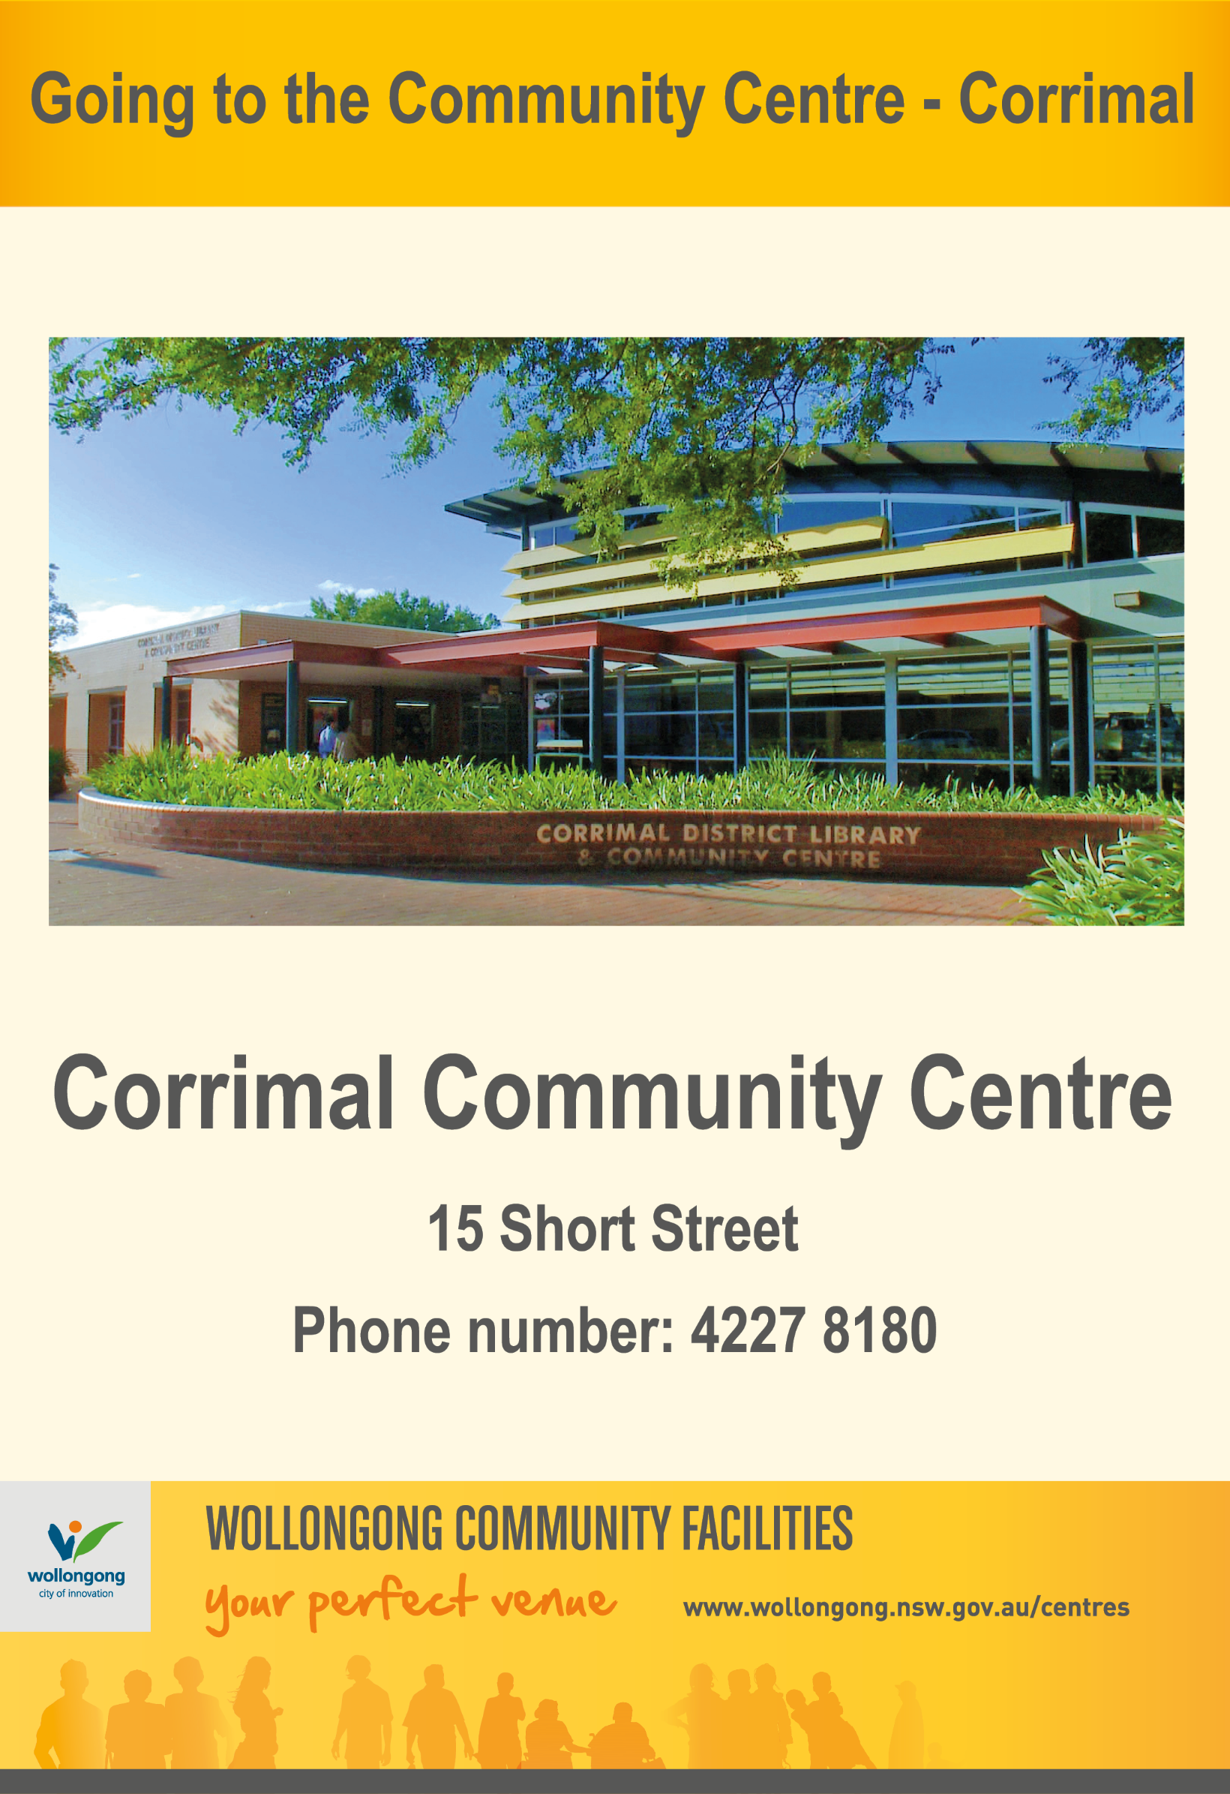
Before I go to the Community Centre

Soon, I am going to the Corrimal District Library and Community Centre. | 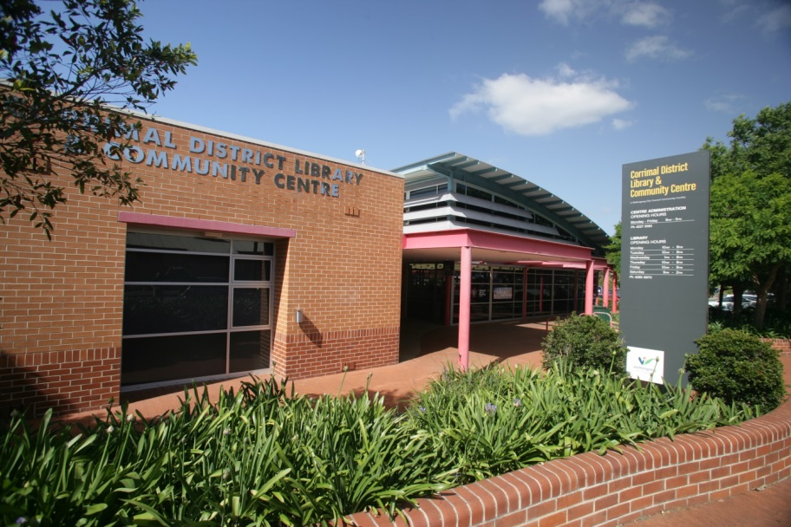
Before I go to the Community Centre, I will need to call the organiser of the activity I want to attend to check if it is still on. | 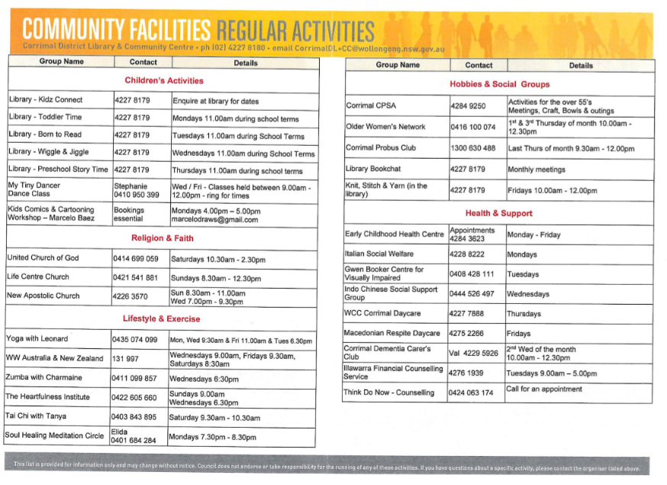
I will not be able to attend the Community Centre, if I am unwell. | 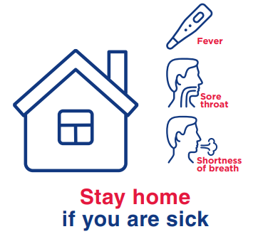

When I visit the Community Centre
To get to my activity, I will need to go through the Entry doors.
There are different rooms for learning, activities, meetings and parties. Some rooms are large and some are small. | 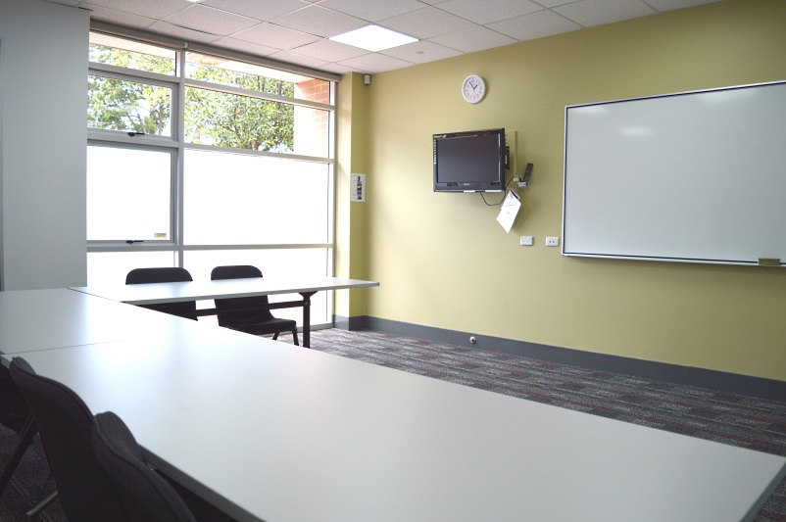  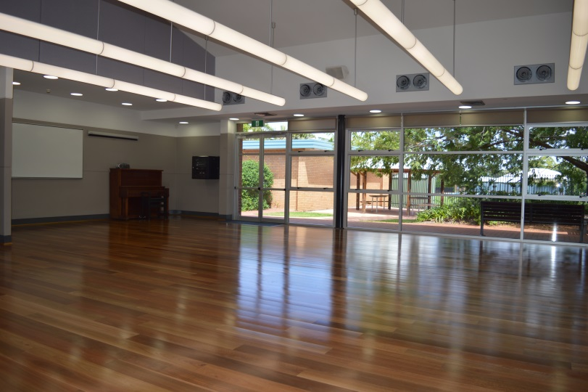
Lots of people go to the centre from babies and families to older people.

While I am at the centre there may be people wearing masks.
The people wearing masks can still talk to me and they might even be smiling.

People might be working or learning so I will need to use my quiet voice when I’m in the centre. If I need to make a small amount of noise that’s ok also. | 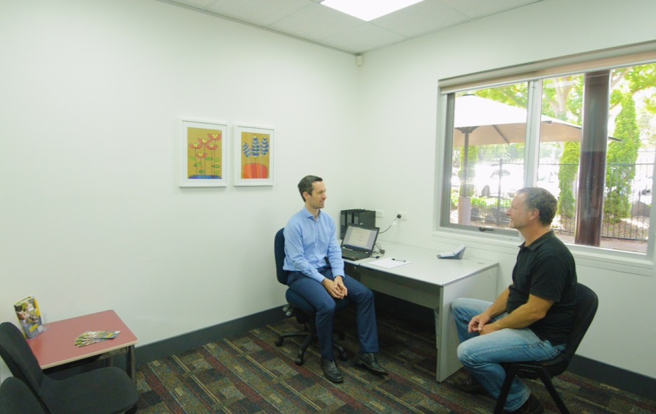
If I am lost or have a question, I can speak to the people working at the front desk. They are very nice and will help me. | 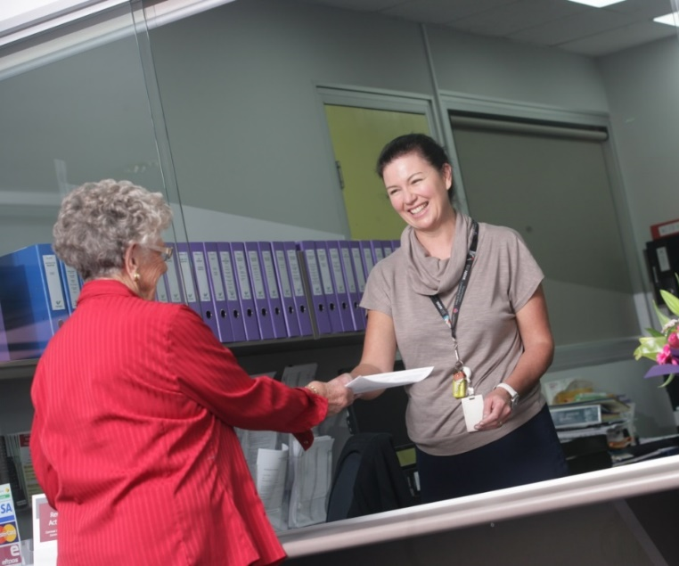
I can ask the front desk for a booklet to find out about different activities held at the Centre. I can take this home and call the phone numbers listed in the booklet if I want to join a group. | 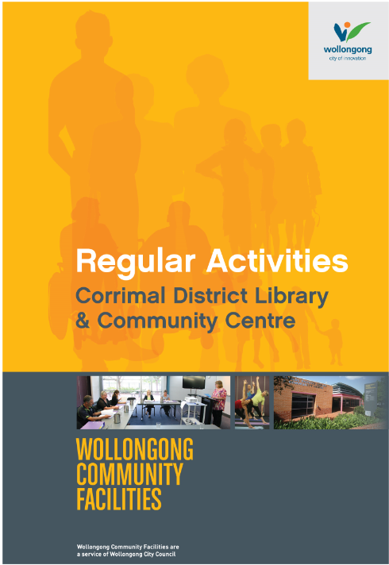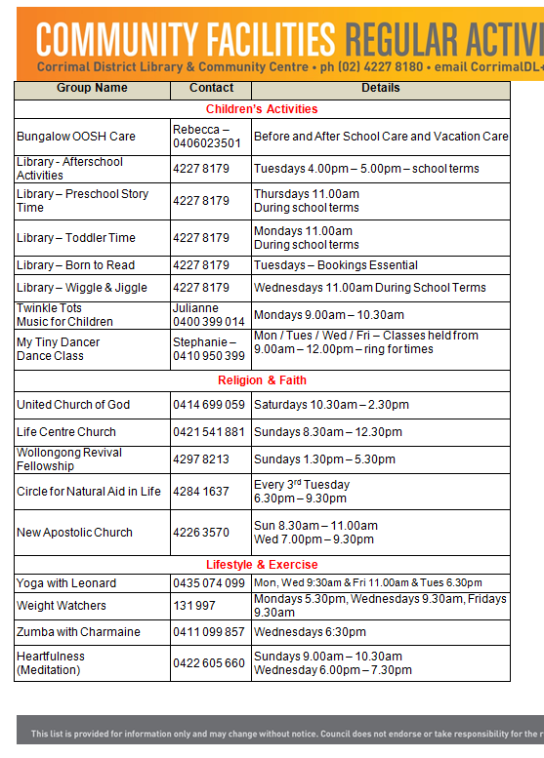
There is a bathroom for me to use if I need to go to the toilet. | 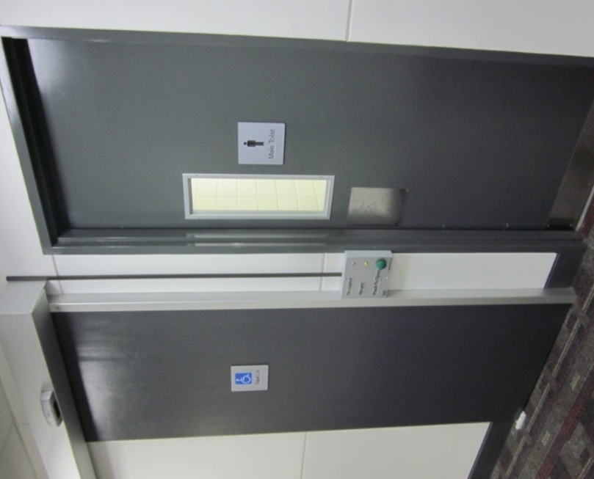
When I leave the Community Centre
When I leave the Community Centre, I need to follow the arrows on the floor showing the way to get to the exit. | 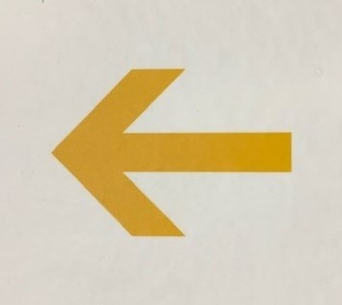
I need to go the exit door.
At the exit door, I need to press the green button to get out. | 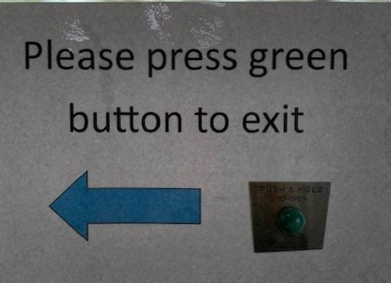

We look forward to seeing you at Corrimal District Library and Community Centre again soon!

FINISHED

