Neighbourhood Forum 5  Wollongong’s Heartland | 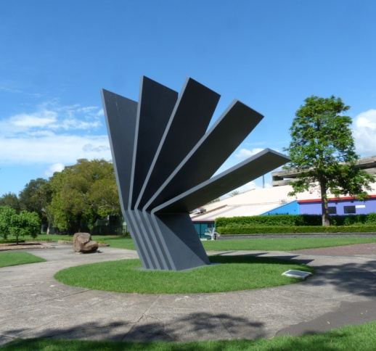 | Coniston, Figtree, Gwynneville, Keiraville, Mangerton, Mount Keira, Mount St Thomas, North Wollongong, West Wollongong, Wollongong City.

Minutes of meeting at 7.00 pm Wed. 3rd July in the Town Hall Ocean Room

Present: 12 members and Clls John Dorahy and Tania Brown

1 Presentations Joe Woodward's presentation was deferred until the August meeting..

2 Apologies were accepted.

3 Minutes of meeting of 5th June 2019 were adopted with no matters arising.

4 Comments Cll Dorahy addressed issues relating to paid parking in the city centre; decline of the Friday markets; maintenance of parks and gardens; and improvements to footpaths and crossover points.
Cll Brown addressed issues relating to lighting and amenities at sports fields; requested members to advise her of "little" jobs needing Council attention; and agreed to follow up on the lack of maintenance of the Cliff Road Battery guns.

5 Responses Green Travel Plans: noted.

Wollongong Bike Plan: noted.

Forest in the City: noted

Delivery Program and Operational Plan: noted

6 Reports draft Economic Development Strategy
It was agreed that the submission be endorsed congratulating Council on their draft Economic Development Strategy 2019-2029 which the Forum fully supports, and request Council to provide adequate resources to ensure progress, monitoring and achievements in accordance with the Action Plan.

Environmental Sustainability Strategy and Policy
It was agreed that the submission supporting the Strategy but with the reservations set out in the report be endorsed.

City Centre Markets; noted

Trees Under Powerlines
It was agreed to:
1 request Council and our local MPs to meet with Endeavour Energy management to discuss how they can:
i review their current practice of tree mutilation which we find unacceptable and totally at variance with that of many other Authorities who are far more sympathetic to the streetscape and sensitivities of residents;
ii set out in detail their proposals to replace trees to be removed and the selection of plants to replace them both under powerlines and elsewhere;
iii set out the consequences for residents who seek to "opt out" of their tree mutilation service;
iv introduce a bundled cable program to obviate the need to prune trees excessively;
v institute negotiations with the State Government to fund a program to eliminate overhead power lines in urban areas as is done in most civilized societies;
2 request our local MPs to approach Matt Kean, Minister for Energy and Environment, to institute an examination of overhead power lines in terms of their social, political, environmental and economic impacts to determine whether or not New South Wales should keep up with most of the western world by eliminating them;
3 request Council to challenge the pruning clearances; formally support the initiatives set out in 1 above, or similar initiatives, and promote them through the Local Government Association
Climate Change
It was agreed in relation to climate change that the Forum adopt as policy and Council be requested to commit to the following actions:
1 Develop strategies to build community resilience and to achieve net zero emissions by 2050 which incorporates the staged implementation of 100% renewable energy, including heating, cooling and transport, by 2050;
2 Develop a Wollongong City Council Energy and Emission Reduction policy to manage energy needs and reduce greenhouse gas emissions across Council operations including waste management, energy management and plant and fleet and built form;
3 Join over 100 other Councils across Australia in signing up to the Cities Power Partnership, a free national local government program that focusses on supporting the emission reduction successes of local councils in Australia. and like Sydney City Council sign up to the Global Climate Action Summit;
4 Immediately elevate climate change issues and risks (environmental, economic and social) in Council decision-making processes;
5 Invest in more climate-resilient infrastructure;
6 Promote mitigation initiatives such as uptake of renewable energy and continue on the adaptation pathway to build local and regional climate resilience;
7 Advancing towards zero waste by meeting, or preferably exceeding, targets in the NSW Government's Waste Avoidance and Resource Recovery Strategy 2014-2021 and comply with the requirements of the Government's 20 year Waste Strategy after it is released - due in early 2020 ;
8 Work with large local industrial players like BHP to achieve sustainable technologies and organisations like Green Connect as well as local farmers to establish local farmers markets;
9 consideration of other strategies such as ensuring new buildings are net zero carbon and achieving an equitable low carbon transformation;
10 Review its insurance cover in relation to the rising tide of litigation on liability risk from climate change.

Wollongong Harbour draft Master Plan
It was agreed that Council be requested to include adequate funding in its budgets to enable completion within the next 5 years of new toilets at Brighton Beach and for a one way loop in Endeavour Drive with improved parking, in accordance with the Wollongong Harbour draft Master Plan.

draft Heritage Strategy: noted

Neighbourhood Forums noted

7 Activities Keiraville/Gwynneville Access Study:
It was agreed that:
1 Council be advised of support for a community engagement program on the draft Keiraville/Gwynneville Access and Movement Strategy provided it is comprehensive including:
i a vision with goals and objectives;
ii data collected including traffic, cycle and pedestrian movements, parking etc. together with future projections;
iii clear statements of how actions are to be prioritised and phased;
iv explicit information on the nature of the draft actions (for example: intersection improvements; traffic calming; safety round schools; or ranger patrols).
2 Council be requested to set up a working group comprising Council, NF 5, the University and the RMS to review progress on implementing the Strategy.
3 Council be urged to meet with Keiraville School on access issues before completing the Strategy
4 Ryan ParkMP, be asked to ascertain the reasons why the Mount Ousely intersection was omitted from the State Budget.

South Wollongong: noted

Neighbourhood Forums Alliance: noted

8 Planning DA/2019/481 22 O'Briens Road Figtree re-subdivision
It was agreed that the submission be endorsed which objects to the proposal unless Council is confident that:
1 a house can be developed on the new lot without overlooking the house to the south;
2 access to the second battleaxe lot to the rear lot is satisfactory;
3 a house can be built on the large rear lot without affecting trees;
4 supplementary plans have been provided clarifying exactly what is proposed and which trees might be affected;
5 a boundary adjustment which creates an extra lot is legal.

DA/2019/518 Dual Occupancy 71 O'Briens Road Figtree
It was agreed that the submission of objection be endorsed.

DA/2019/506 Boarding House, 12 Dallas St Keiraville
It was agreed that the submission of objection be endorsed.

DA/2019/556 Dual Occupancy, 13 Sheppard St West Wollongong
It was agreed that the submission of objection be endorsed.

DA/2019/547 Dual Occupancy, 4 Allan Street Wollongong
It was agreed that the submission of support be endorsed.

DA/2019/571- Dual Occupancy, 51 Hillcrest Street, Wollongong
It was agreed that a submission of support be submitted.

DA/2019/620- Dual Occupancy, 23 Figtree Crescent, Figtree
It was agreed that a submission of support be submitted.

9 General Emergency Plans
Business It was agreed to request the State Government to review its emergency planning measures when accidents occur, such as that recently which closed the Freeway and created gridlock in the City for several hours.

Medium Density Code
It was agreed that the implications of this should be reviewed and appropriate action taken if necessary.

10 Snippets noted

Next Meeting: 7.00 pm on Wed. 7th August 2019, Town Hall Ocean Room.

Current active membership of Neighbourhood Forum 5 : 388 households

