Neighbourhood Forum 5  Wollongong’s Heartland | 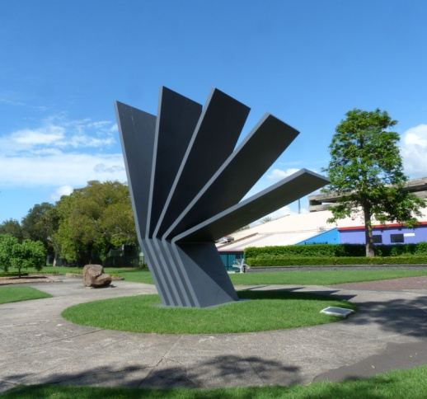 | Coniston, Figtree, Gwynneville, Keiraville, Mangerton, Mount Keira, Mount St Thomas, North Wollongong, West Wollongong, Wollongong City.

Minutes of meeting at 7.00 pm Wed 5 June 2019 in the Town Hall Ocean Room

Present: 14 members & Cllr Tania Brown

1 Presentations Mike Dowd was thanked for his well prepared presentation on Agenda items 6.1, 6.5, 7.1, 7.3, 7,5-7.8 and for responding to questions, which helped in developing the recommendations.

2 Apologies were accepted.

3 Minutes of meeting of 1 May 2019 were adopted with no matters arising.

4 Comments were made during Mike Dowd’s presentation.

5 Responses 5.1 Parking at North Wollongong Station: noted.

5.2 Crown Street Markets
It was agreed that Council be requested to advise:
1 how management has been improved, because our feedback from stallholders is that it is not working satisfactorily?;
2 whilst support for locally authentic new products and new start-ups or home based businesses are clearly desirable, how has this affected long-term traditional stallholders?;
3 what " wide variety of entertainment and activities in association with the market" have been provided and/or are proposed?;
4 what performance measures are in place, for example - number of people in the Mall on market days; and the numbers, stability and satisfaction survey of stall holders?;
5 given the apparent decline in providers and customers, what steps is Council taking to retrieve the situation?

6 Reports 6.1 Forest in the City
It was agreed to congratulate Council on the initiative of tree planting in the retention basin and flood area at Nyrang Park detention basin, and request Council to advise whether/how it is intended to use this method for other suitable areas in the LGA.

6.2 Boarding Houses
It was agreed that Council be requested to advise if/when it proposes to use the clear definition of a Boarding House in legislation for development assessment purposes, particularly in the Keiraville/Gwynneville area.

6.3 Development Register
It was agreed that Council be requested to ensure that all documentation relating to a development application is posted on their web site from the time of first notification, and not removed during the assessment period.

6.4 Definition of Stories
It was agreed that Council be requested to advise their interpretation of the definition of a storey when assessing development proposals.

6.5 Wollongong Harbour
It was agreed to advise Crown Lands the Forum supports their draft Master Plan for Wollongong Harbour, which is a welcome contrast to their 2010 plans, and requests reconsideration of the proposed future boardwalk across the end of the pier and associated beach which could be restrictive for water craft.

7 Activities 7.1 Keiraville/Gwynneville Access Study
It was noted that Council are inviting attendees at previous workshops to a presentation on Wed 12 June at 4pm on level 10 committee room 2 re strategies and actions to be included in the final document, and the study will be reported to Council recommending a public exhibition period.

7.2 Climate Change Group: noted

7.3 South Wollongong Flooding
1 It was noted that residents raised major concerns at the 1 June information session for the City Flood Study and
2 it was agreed that Council be requested to include NF5 representatives on a review committee to investigate and assess possible solutions to flooding experienced in the South Wollongong area.

7.4 Neighbourhood Forums Alliance: noted

7.5 Re-opening Cliff/Bourke Intersection: noted

7.6 Continental Pool Access
It was noted that a meeting with NF5 representatives will be held at Council on Wed 19 June at 9.30am to further discuss restoring access at the pool for people with disability.

7.7 Foreshore Parking Strategy
It was noted that Council are progressing with development of a Foreshore Parking Strategy. Information has not yet been provided on the review of the Blue Mile Master Plan due in 2018/19.

7.8 Denison St Shared Path
It was noted that Council proposes a 2 way shared path on the eastern footpath of busy Denison St between Throsby Drive and Crown St for pedestrians and cyclists. Its effectiveness will be assessed in due course.

7.9 Crown Land Plans of Management
1 It was agreed that Council’s General Manager be requested to arrange a meeting with representatives of NF5 to develop an effective Community Engagement process for development of Plans of Management for regionally significant Crown Reserves, such as for Stuart Park, to ensure the PoMs will comply with the requirements of the Crown Land Management Act 2016, and
2 It was agreed to authorise the Executive to discuss with the proponent of a secondary motion and resolve.

7.10 Council Policies: noted

8 Planning 8.1 DA-2019/388 Dual Occupancy 55 Mt Keira Rd West Wollongong
It was agreed that the submission of objection be endorsed.

8.2 DA-2019/428 Dual Occupancy 26 Foley Street Gwynneville
It was agreed that NF5 advise the assessing officer that, following representations from affected residents, NF5 supports objections, including re non-compliances, scale, bulk, overdevelopment, site suitability, loss of privacy and sun, and effects of on street parking.

8.3 DA-2019/447 Museum 143 Gipps Road, Keiraville
It was agreed that the submission of support be endorsed.

8.4 DA-2019/469 Dual Occupancy 55 Grey St Keiraville
It was agreed that the submission of support be endorsed in general, but that assessing officer/s be requested to take into account concerns about the effects of garage doors which do not comply in width.

8.5 DA-2019/416 Dual Occupancy105 Walang Ave Figtree
It was agreed that the submission of support be endorsed.

8.6 DA-2018/473 Commercial & Residential 49-51 Denison St Wgong
It was noted that WLPP deferred this for changes and resubmission.

8.7 DA-2018/1231 North Wollongong Surf Club major alterations
It was noted that NF5 submission included concerns re heritage and impacts of sea level rises. On 22 May WLPP considered representations on heritage issues, deferred the DA for changes, and delegated determination to Council’s relevant Manager.

8.8 Low Rise Medium Density Housing Code
It was agreed that Council be advised that NF5 supports preferably exclusion or further deferral of implementing the Low Rise Medium Density Housing Code.

8.9 DA2018/1484 Residential Flats 21-23 Mercury & 57 Bligh Wgong
It was noted that on 29 May WLPP deferred the DA for changes, and delegated determination to Council’s relevant Manager.

9 General /
Late Business 9.1 Appointment of WCC General Manager
It was agreed that Council be advised NF5 welcome the appointment of Greg Doyle as Wollongong’s General Manager and we look forward to working collaboratively with Greg and staff.

9.2 Environmental Sustainability Strategy and Policy
]t was noted that Council’s website includes that a process recently started to revise the existing Environmental Sustainability Strategy and Policy, that are on public exhibition. Submissions close 24 June.

9.3 Coniston Beach Dunes - bitou bush spraying late June
It was noted that Illawarra District Weeds Authority (ph 4233 1129) have advised they propose aerial spraying of bitou bush at Coniston Beach in late June, conditions permitting. Safety measure will be in place and low toxicity Brush-Off (no relation to glyphosate) will be used, which has proven selective to bitou elsewhere. This is the first stage, to be followed by hand spraying/removal and planting native species.

10 Snippets 10.1 Place Quality: noted

10.2 Street Art Crown Street West? noted

Next Meeting: 7.00 pm on Wed. 3rd July 2019, Town Hall Ocean Room.

Current active membership of Neighbourhood Forum 5 : 392 households

