

**Going to**

**Comic Gong 2025**

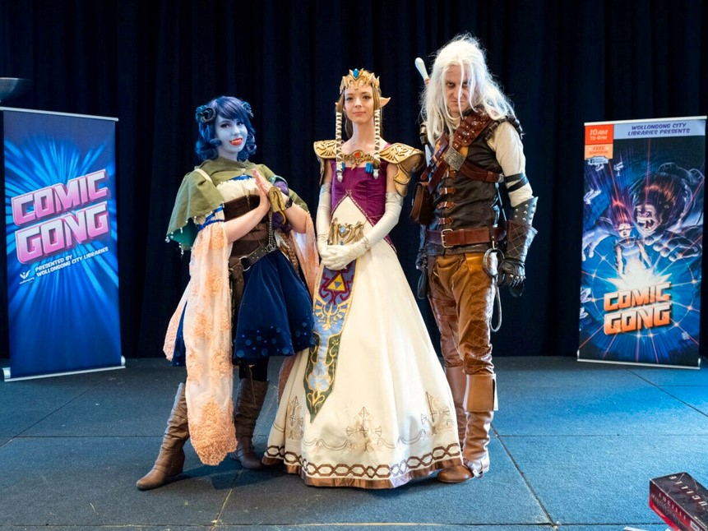

|  |  |
| --- | --- |
| On Saturday 24th May I am going to Comic Gong. |  |
| Comic Gong is free, but I can bring  money to buy food  or souvenirs. |  |
| Lots of people attend Comic Gong and it can be noisy. I can wear ear plugs or bring anything else that will help me have a good time. |  |

|  |  |
| --- | --- |
| Comic Gong will  be held at Dapto Ribbonwood  Centre. |  |
| There are artists  stalls in the  Kurrajong Hal and trade stalls in the Scribbly Gum room and foyer where I  can look and buy merchandise. |  |
| Dapto Library upstairs has board games, face painting, craft, glitter tattoos and author’s selling their books. |  |

|  |  |
| --- | --- |
| The Heininger Hall has cosplay competitions. |  |
| There are arcade games in the  Acacia room. |  |
| The Laurel room will have robotics. |  |

|  |  |
| --- | --- |
| I can find toilets including accessible toilets in the ground floor foyer and outside Heininger Hall. |  |
| I can visit The Quiet Space in the Banksia room to take a break from the crowds. |  |
| If I have questions about where to find things, I can ask one of the volunteers or events staff. |  |

|  |  |
| --- | --- |
| I can scan this QR  code if I want more information. | wollongong.nsw.gov.au/comicgong |
| If I need something  to help me have a  good time at Comic Gong I can contact comicgong@wollo ngong.nsw.gov.au |  |
| **FINISHED**      We hope you had a great time at Comic Gong 2025! | |