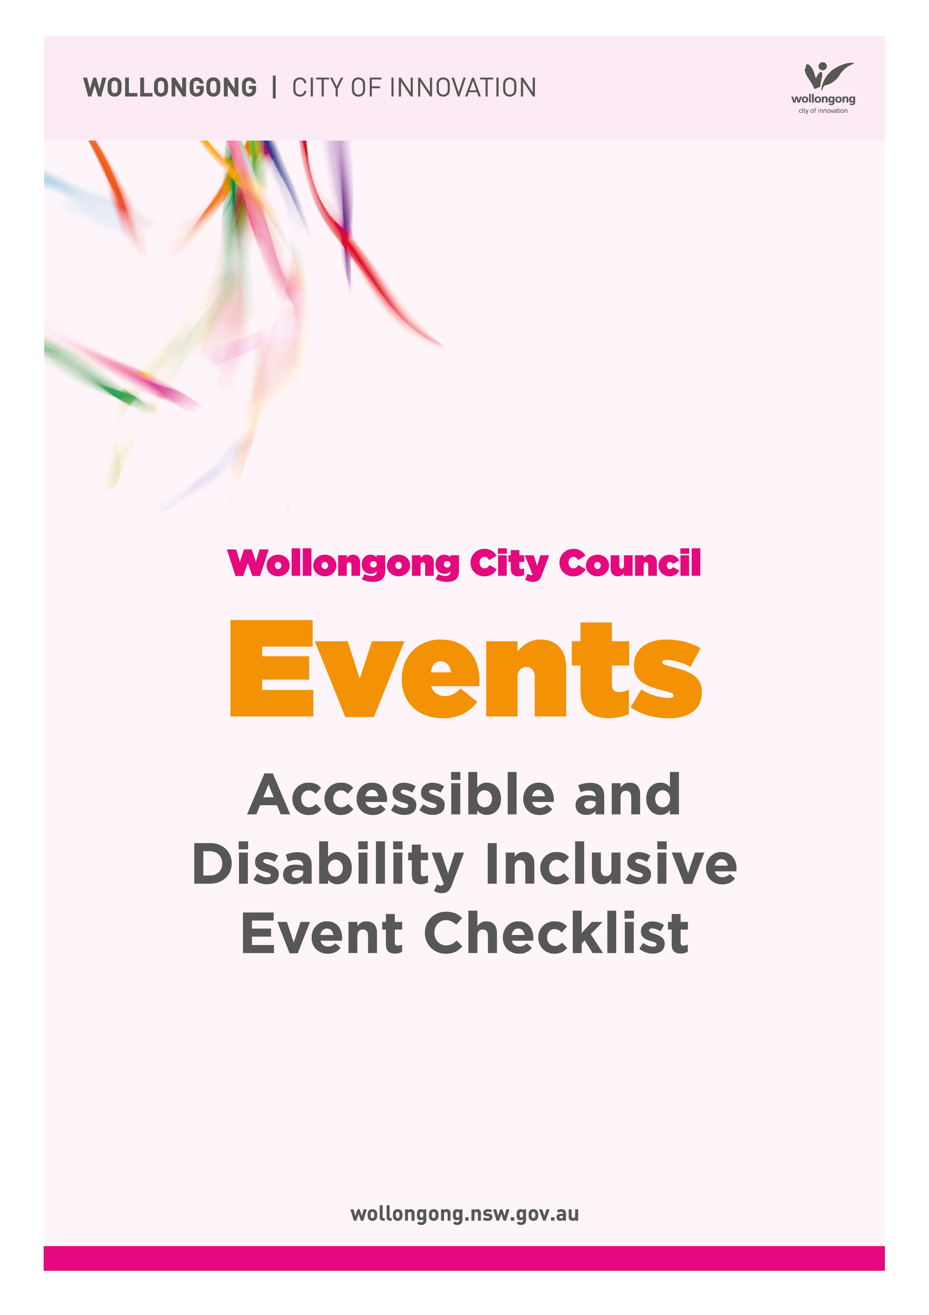

Accessible & Disability Inclusive Community Events
This checklist is certainly not exhaustive, however should prompt us to consider access and inclusion for all events. Some disabilities may be obvious such as people who use wheelchairs or have a vision impairment, however many disabilities are invisible. This checklist will give ideas, however, where possible it’s always best practice to ask the person (or group of people) what supports they need to participate.

Why are accessible & inclusive community events important?
- People with disabilities need to know they are welcome, invited and valued as part of the community. They need to know they won’t be judged and will be safe and understood.

- Making your event accessible and inclusive is good business.

- The Disability Discrimination Act (DDA) (1992) covers the areas of employment, access to goods, services and facilities, education, access to premises and transport. The DDA states that people with disabilities cannot be discriminated against due to their disability and where barriers exist, all reasonable measures must be taken to remove them.

Strategy | Who it helps
Area 1 Communication
Visual map/mud map of event with accessible and inclusive elements identified and continuous paths of travel clearly marked. | - The whole community.
Website meets W3C accessibility standards. | - People who are blind or have low vision.
Information regarding accessible and inclusive elements are easily found on the website to support people to plan their event experience. Use appropriate and easy read language. | - Anyone with a disability and their family.  - Families with small children.  - Older people.
All promotional material follows Vision Australia ‘Online and print inclusive design and legibility  considerations’.  https://www.visionaustralia.org/services/digital-access/blog/12-03-2014/online-and-print-inclusive-design-and-legibility-considerations | - People who are blind or have low vision.

Strategy | Who it helps
Area 1 Communication
Ensure promotional material includes some information about access and inclusive elements and details of where people can get more detailed information. | - Anyone with a disability and their family.
Ensure contact name, phone number and email address on website so people can ask specific questions if needed. | - Anyone with a disability and their family.  - Older people.
Consider the use of a social story-available on Council’s website, in hard copy and on social media. This helps prepare people for what to expect at the event. | - People with a disability.  - People from a culturally and linguistically diverse background.  - People with low literacy.
Consider if event information is needed in large print, braille or audio. | - People who are blind or have low vision.
Promote use of companion card. | - People with a disability.

Strategy | Who it helps
Area 1 Communication
Target disability groups and organisations to invite them to the event. Suggestions may include (but not limited to):  - The Disability Trust  - The Shepard Centre  - Vision Australia  - The Flagstaff Group  - ASPECT (Autism Spectrum Australia)  - Greenacres  - The Benevolent Society  - Lifestart (NDIS planning for children under 7 years of age)  - Uniting NDIS (NDIS planning for people aged 7-65 years)  - Uniting Ability Links (work with people over 8 years of age)  - Life without Barriers  - House With No Steps  - Guide Dogs NSW/ACT  - The Deaf Society  - Interchange Illawarra  - Spinal Cord Injuries Australia  - Northcott  - Cram Foundation  - Department of Education (support units)  - Catholic or private schools with support units | - The whole community.

Strategy | Who it helps
Area 1 Communication
Consider promoting ‘quieter’ times | - People with sensory sensitivities such as Autism Spectrum Disorder.  - Families with small children.  - Anyone who wants to participate but finds large crowds overwhelming.
Consider audio guides and descriptions for exhibits and displays. | - People who are blind or have low vision.

Strategy | Who it helps
Area 2 Transport
Ensure accessible parking available with paths of travel into event. | - People with disability and their families.
Ensure drop off/pick up zones with pathways of travel into event. | - People with disabilities.

Strategy | Who it helps
Area 2 Transport
Ensure good connection with transport services such as taxi, bus and train. | - The whole community.

Strategy | Who it helps
Area 3 Venue
Consider overall accessibility of the venue.  If it will be costly to make it accessible maybe consider an alternate venue. If the venue is multistory are there lifts? What would happen in an emergency? Do the doors self-open? | - The whole community.
Consider paths of travel for entry, exit, amenities and around event. Watch for lips, potholes, steps, trip hazards etc.  No overhanging foliage on paths. Document which areas of the event are inaccessible. | - People with disability.  - Older people.  - Families with prams.
Are there accessible toilets on site or will you bring them in? Ensure they are in good working order and that you have enough for the number of people expected at the event. | - Anyone with a disability who requires an accessible toilet.

Strategy | Who it helps
Area 3 Venue
Ensure paths of travel around event have visual contrast (i.e. are clearly marked), are wide and nothing blocking them (e.g. signs or overhead trees hanging down). | - People who are blind or have low vision.  - People with mobility challenges and/or who use mobility aids.  - Families with prams.
Consider path surfaces. Is matting needed to make it slip resistant or suitable for a wheelchair or scooter? | - People with mobility challenges.  - People who use mobility aids.
Ensure stalls have lowered counter height space. | - People who use wheelchairs.  - People of small stature.
Consider accessible menus for stalls e.g. visuals/large font/braille. | - People who are blind or have low vision.  - People with cognitive disability or brain injury.
Ensure way finding signage is accessible-large print, visuals. | - The whole community.
Consider hearing augmentation system and/or Auslan translator for speeches. | - People with hearing loss.  - Older people.

Strategy | Who it helps
Area 3 Venue
Consider closed captioning for films | - People with hearing loss.  - Older people.  - People with Autism. Spectrum Disorder (who may have challenges in processing verbal information).
Consider an accessible viewing area | - People of short stature.  - People who use wheelchairs or scooters.  - People who need quick and easy access exiting the event.  - People who need to sit due to their disability or medical condition.
Target performers/artists/stall holders etc. who have a disability to participate in the event. Ask them if they require any adjustments. | - The whole community.

Strategy | Who it helps
Area 3 Venue
Space for assistance animals (including grass and water) | - Any person with a disability who has an assistance animal e.g. autism assistance animal, guide dog.
Quiet area for people to take a break (including shade, seating and sensory play activities for calming) | - People with sensory sensitivities such as Autism Spectrum Disorder.  - Older people.  - People affected by glare.  - People with medical conditions.
Warn participants about any loud noises, lighting effects or special effects that will be about to occur. | - People with sensory sensitivities.  - People who are blind or have low vision.  - People with Epilepsy.
Ensure free drinking water is available and clearly sign posted at the event and on maps. | - The whole community.

Strategy | Who it helps
Area 3 Venue
Stall holders, volunteers and security to have pen and paper for information exchange if needed. | - People with hearing loss.

Strategy | Who it helps
Area 4 Disability Awareness Training
Volunteers and security received disability awareness training. | - The whole community.
Consider contacting an access specialist to assess the event and provide suggestions. | - Anyone who has a disability and their family.

References & further information:
- Institute of Access Training Australia (2012) How to Provide Better access to Festival and Outdoor Events. Achieveability Pty Ltd. Series 2, Handbook 3, 2nd edn.
https://accessinstitute.com.au/product-category/handbooks/online-handbooks/
- Institute of Access Training Australia (2012) How to Develop More Accessible Communications. Achieveability Pty Ltd. Series 5, Handbook 4, 2nd edn.
- Meetings and Events Australia (2012) Accessible Events: A Guide for Meeting and Event Organisers.
http://www.meetingsevents.com.au/downloads/Accessible_Events_Guide.pdf
- Central Coast Council (2018) Planning accessible Events: Guide and Checklist.
https://cdn.centralcoast.nsw.gov.au/sites/default/files/Central-Coast-Council-How-To-Plan-Accessible-Events-Standard.pdf
- Vision Australia (2014) Online and Print Inclusive Design and Legibility Considerations (blog post).
https://www.visionaustralia.org/services/digital-access/blog/12-03-2014/online-and-print-inclusive-design-and-legibility-considerations

- ASERT (Autism Services, Education, Resources and Training Collaborative) Hosting a Sensory Friendly Event
http://www.paautism.org/desktopmodules/asertapi/api/item/ItemDetailFileDownload/4042/Hosting%20a%20Sensory%20Friendly%20Event.pdf

If you require further information about how to make your event more accessible and inclusive, please contact Wollongong City Council Events Team or Ageing and Disability Community Development Officer on 42277111.

