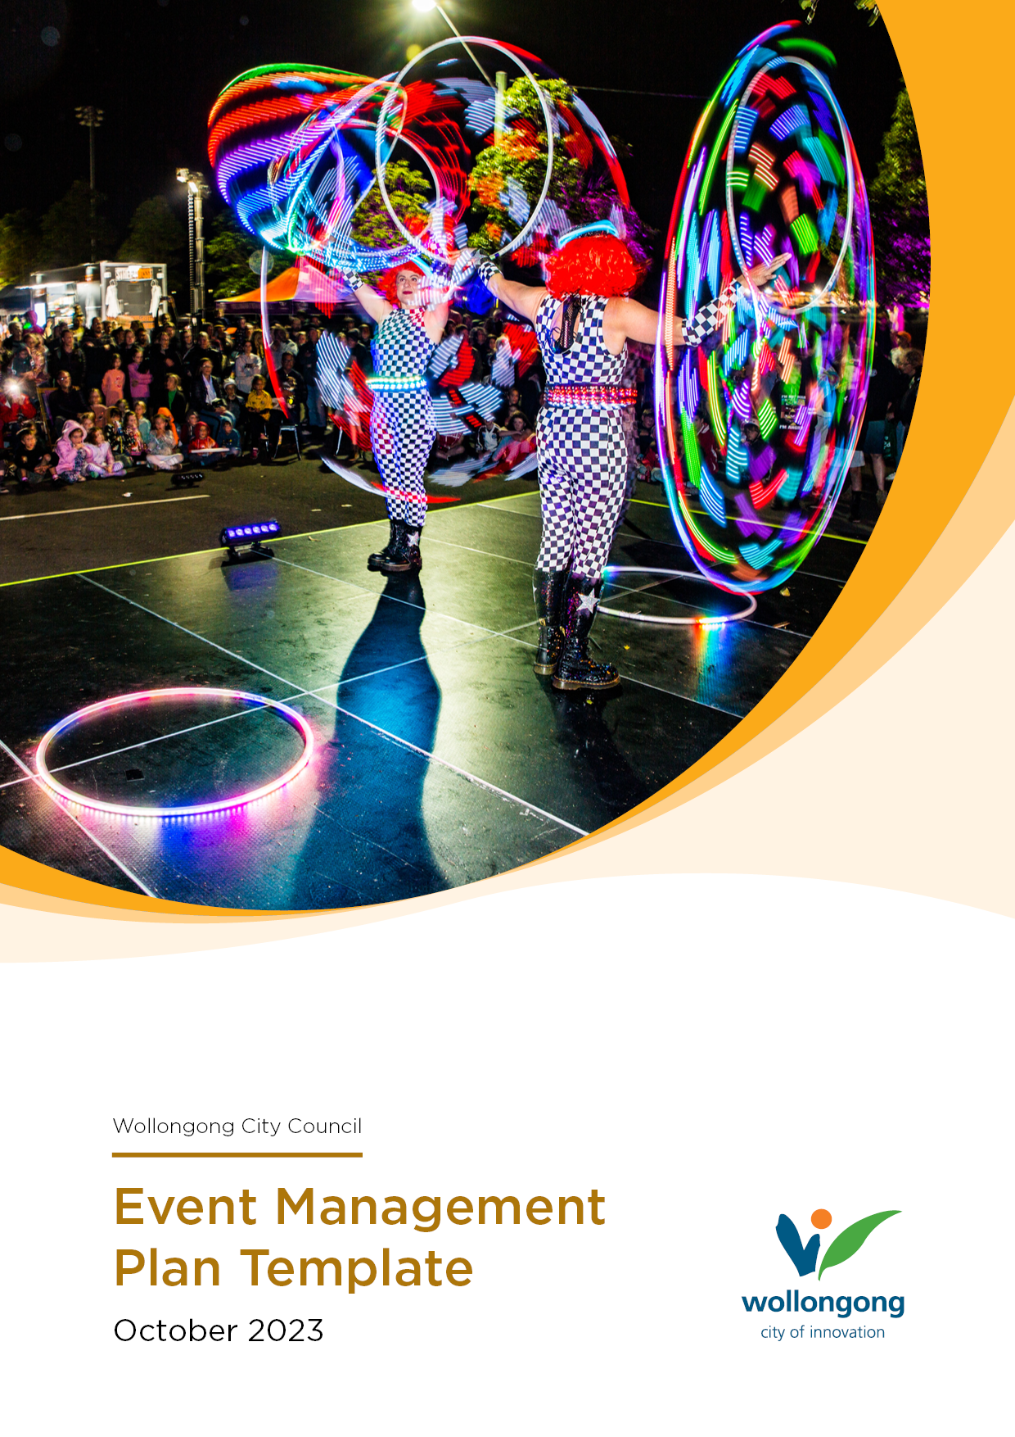

<INSERT EVENT NAME HERE>

Event Management Plan
for
Small to Medium Events

Document Control
Document Created:
Document Last Edited:
Document Edited by:
Email:

A copy of the Event Management Plan should be retained by the
event organiser for use on the day of the event.

This template is not limited to the information contained and not all sections will be applicable to your event. Please provide any additional information that may assist with the management and planning of your event.

Disclaimer

TABLE OF CONTENTS
1 | Introduction

PART A

INTRODUCTION
An Event Management Plan (EMP) helps event organisers to meet their responsibility for the health and safety of workers, volunteers, and attendees. This plan should identify and ensure specific plans and arrangements are in place to manage risks associated with staging of the event and to ensure the event is successful.
Wollongong City Council is committed to ensuring the health and safety for anyone organising and attending events and no damage to environment or property is caused because of the event.
Council requires all event organisers to complete an Event Management Plan. The Event Management Plan must be supported by a Risk Assessment, Traffic Management Plan (if required) and evidence of Public Liability Insurance.
When completing this Plan please answer all questions. If the question is not applicable to your event, please mark N/A.
Should you require any assistance completing the document, please contact the Events Team.

Event Details
Event Name
Type of Event | e.g., Cultural Festival/Music/Markets
Date/s
Location
Expected Number of Attendees
Is the event ticketed | ☐Yes ☐ No

Event Description
Event Description
(e.g., type of event, target audience, event highlights and entertainment)

Event Organiser’s Details
Event Organiser
Organisation/Committee
Contact Phone Number
Email Address
Postal Address

Event Schedule

Include the bump in/out dates and times for the venue and any major events/activities during the event.
Date/Time | Activity
e.g.  01/01/2021  6.00am  8.00am | Bump In  Staff arrive on site.  Contractor arriving for XXX
 | Insert additional rows in table as needed

PART B

EVENT REQUIREMENTS

2.1 Site Map
Attach your event site plan to this document. An Event Site Map Template is available on Wollongong City Council’s website.
Site plan attached | ☐ Yes ☐ No
Check List

☐ Surrounding roads

☐ Event boundary
☐ Car parking
☐ Emergency vehicle access
☐ Emergency exits.
☐ Emergency assembly areas
☐ First aid location/s
☐ Stall locations
☐ Stage/temporary structures
☐ Amusement operators
☐ Amenities (toilets)
☐ Bins
☐ Water

2.2 Risk Assessment
Attach your completed Risk Assessment to this document. A Risk Assessment must be completed prior to the event and should identify, assess, and control all risks relevant to the event. You can use the template available on Council’s website to develop your own Risk Assessment.
All risks have been identified | ☐ Yes ☐ No
Risk assessment attached | ☐ Yes ☐ No

2.3 Public Liability
Attach a copy of your Public Liability Insurance Certificate with this document. Public liability insurance must include Insurer details, date of cover, amount of cover (no less than $20 million), and Wollongong City Council to be an interested party. This ensures Council is indemnified from any loss, damage or personal and public injury arising from your event.

Public Liability Insurance Certificate attached | ☐ Yes ☐ No

2.4 Traffic Management Plan (if applicable)
Where an event is likely to affect traffic conditions or require a temporary road closure on any Council roads, or State Government roads, organisers are required to seek approval from the Traffic Committee
Attach Transport Management Plan and any relevant Traffic Control Permits (if applicable) to this document if this is required for your event. You can use the template available on Council’s website to develop your own Traffic Management Plan.
Transport Management Plan attached | ☒ Yes ☐ No ☐ N/A

2.5 Notification Plan
To minimise any impact on surrounding residents and businesses you are required to notify and consult with the community and businesses located near to your event.
A formal letter must be sent to all stakeholders within the event precinct at least 30 prior to the event. The Events Team can help you develop a list of who should be targeted directly and identify the areas and streets to be included in your distribution.
Your letter must be on your official letterhead and include the following details:
- the name, date, and location of your event (including bump-in and bump-out times)
- the purpose of the event
- the expected number of attendees
- activities being conducted as part of the event.
- what the likely disruptions to residents and businesses will be with respect to noise, transport, and road closures
- a contact number (before and during the event) for further information or queries
An example notification letter can be found on Council’s website.
How will you advise the community?
(i.e., letterbox drop, social media posts etc.)
Will you be using VMS boards? | ☐ Yes ☐ No
When will you notify the community?
Additional details/comment
Map of notification area (attached) | ☐ Yes ☐ No

PART C

PUBLIC HEALTH

3.1 Food Vendors
Provide a list of food vendors (both temporary food stalls, mobile food vehicles, caterers etc). You will also be required to check each food vendor holds a current Food Business Licence and ensure a copy of their current certificate is provided to Council prior to the event (certificate must also be displayed at each stall).
Business Trading Name | Contact Number | Type of licence (i.e. temporary food stall, mobile food vehicle etc)
e.g. The Potato Van | 04XX XXX XXX | Mobile Food Van
 |  | Insert additional rows in table as needed

3.2 Alcohol
Provide information relating to alcohol being sold/served at the event. You will need to provide a copy of your Liquor Licence (where applicable).
Will alcohol be at the event? | ☐ Yes ☐ No
Has the liquor licence been attached? | ☐ Yes ☐ No ☐ N/A
Additional details/comments

3.3 Toilet Facilities
Provide details on the number of toilets that will be available or supplied at the event. Toilets must be provided with soap, running water and paper towels. Refer to the Event Planning Information for a guide on how many toilets are required for the event.
Amenity Type | Number of toilets
Male
Female
Disabled
All toilets provided with hand washing (including soap and paper towel)? | ☐ Yes ☐ No
Toilets marked on site map | ☐ Yes ☐ No

3.4 Cleaning and Sanitising
Provide details on how the facilities and event grounds will be cleaned and serviced during/after the event.
Will a cleaning roster/procedure be implemented for the event? | ☐ Yes ☐ No
Provide details (i.e. external cleaning contractor or event staff, cleaning and sanitising methods and frequency).

3.5 Water Supply
Provide information on water supply that will be made available at the event e.g. will there be an adequate supply of potable water for drinking?
Will there be potable (drinking) water be at the event? | ☐ Yes ☐ No
Provide details

3.6 Waste Management
Provide information on the number of general waste and recycling bins that will be at the event. Provide the waste contractor’s details and how waste will be handled/disposed of during and after the event. Refer to the Event Planning Information for recommended number of bins to be provided.
Waste contractor/s
details
No. General waste bins |  | No. Recycle bins |  | No. Skip bins
Bins marked on site map | ☐ Yes ☐ No

3.7 Environmental Impact
While conducting the event you must take all reasonable and practical measures to minimise environmental impacts and nuisances to the surrounding community and businesses.
Provide information on the activities that are likely to cause a nuisance during the event (such as noise from music) or an environmental impact (such as spills or waste that require clean up) and address how these will be monitored, minimised, or controlled.
Type of impact | Likely to occur | Details
Noise (i.e. music, PA announcer etc) | ☐ Yes ☐ No ☐ N/A
Obtrusive lighting | ☐ Yes ☐ No ☐ N/A
Dust/fumes/smoke | ☐ Yes ☐ No ☐ N/A
Liquid spills or waste requiring clean up | ☐ Yes ☐ No ☐ N/A
 | ☐ Yes ☐ No ☐ N/A | Insert additional rows in table as needed

PART D

SAFETY

4.1 First Aid
It is the organisers responsibility to provide a safe and healthy environment for those attending and working at their event.
Provide details of the first aid provisions that will be available at the event. Include information on the number of first aid personnel, first aid posts and qualifications.
Number of first aid stations
Details of first aid officer/s (include company and individual name) |  | Are they qualified?
 |  | ☐ Yes ☐ No
Insert additional rows in table as needed |  | ☐ Yes ☐ No

4.2 Incident Reporting
During the event it is important to make a record of incidents and near misses that occur. These should be logged in a format that includes date & time of incident, description of what occurred, person involved, and action taken.
Will incidents and near misses be reported? | ☐ Yes ☐ No
Provide details on how these will be reported (i.e. what method will be used for reporting).

4.3 Signage (inside the event)
Ensure applicable signage is displayed inside the event for safety and communication to attendees. Provide information on signage that will be installed.
Signage | Provided | Details
Entry/Exit | ☐ Yes ☐ No
Information Point | ☐ Yes ☐ No
No Smoking / Smoking Areas | ☐ Yes ☐ No
Alcohol Consumption Area/s | ☐ Yes ☐ No
Alcohol Consumption Rules | ☐ Yes ☐ No
First Aid Location/s | ☐ Yes ☐ No
Toilets | ☐ Yes ☐ No
Drinking Water | ☐ Yes ☐ No
 |  | Insert additional rows in table as needed

4.4 Power Supply
Provide a description of the power supply for the event. Information should include if the supply is from a generator or another source. Refer to the Event Planning information for electrical information and additional connection fees that may be required.
Will power be needed at the event? | ☐ Yes ☐ No
Detail how this will be supplied (i.e. power from venue or generator, will a licensed electrician be conducting the work).

4.5 Lighting (if applicable)
Provide information on the lighting that will be provided at the event. If your event is in the evening, consider lighting that may be necessary to ensure safety of attendees at the event and entering/exiting the event.
Will sufficient lighting be at the event to ensure safety? | ☐ Yes ☐ No ☐ N/A
Detail the type of lighting that will be installed (ensure this is included on your site map also).

4.6 Temporary Structures (if applicable)
Provide information on any temporary structures (staging,marquees and tents) that will be erected at the event. Refer to the Event Planning Information on Council’s website for information about requirements for temporary structures.
Type of structure | Certificate attached or can be provided later
 | ☐ Yes ☐ TBA
 | ☐ Yes ☐ TBA
Insert additional rows in table as needed | ☐ Yes ☐ TBA

4.7 Amusement Operators (if applicable)
Under the Work Health and Safety (WHS) legislation, event organisers responsibility to provide a safe and healthy environment for those attending and working at their event.
This includes having some management or control of amusement devices, including inflatable devices, regardless of whether you directly hire the amusement devices, rent out space to the amusement device operator/s, or something in between.
Visit SafeWork NSW for more information and guidance materials for event organisers.
All Amusement Devices are required to be registered with SafeWork NSW. List all amusement ride operators and provide a copy of their in-date NSW SafeWork Plant Registration.
Operator Name | Type of amusement device | Certificate attached
 |  | ☐ Yes ☐ No
 |  | ☐ Yes ☐ No
 | Insert additional rows in table as needed | ☐ Yes ☐ No

Amusement Operators are also required to maintain an Operation and Maintenance Logbook. Council retains the right to sight the logbook as requested.

Amusement Operators must provide a current Public Liability Insurance Certificate. Public liability insurance must include Insurer details, date of cover, amount of cover (no less than $20 million), and Wollongong City Council to be noted as an interested party. This ensures Council is indemnified from any loss, damage or personal and public injury arising from the amusement ride.
Operator Name | Public Liability Certificate attached
 | Public Liability Certificate attached | ☐ Yes ☐ No
 | Public Liability Certificate attached | ☐ Yes ☐ No
 | Insert additional rows in table as needed | ☐ Yes ☐ No

4.9 Fireworks (if applicable)
If you want to hold a fireworks display, you will need to follow the guidelines set by SafeWork NSW, and advise Council at least five working days in advance.
Council can apply conditions to your fireworks display, or even object to it going ahead.
Refer to our Event Planning Information for more detail of what is required and how to notify Council.
Attach relevant contractor’s licence and their public liability if a fireworks display is proposed for the event.
Contractor’s Licence & Public Liability attached | ☐ Yes ☐ No ☐ N/A

PART E

EMERGENCY RESPONSE PLAN

5.1 Primary Contact
The Primary Contact is the person who acts as the main contact person for the Organisation/Event in an emergency. The Primary Contact is responsible for making decisions and following the steps described in this emergency response plan. A Secondary Contact is required to act as the Primary Contact if they become unavailable.
Primary Contact | Secondary Contact
Name: | Name:
Contact No: | Contact No:

5.2 Emergency Contacts
Primary Emergency Contact DIAL 000
Police | Fire
Local Station: | Local Station:
Contact: | Contact:
Number: | Number:
SES | Local Hospital
Emergency No: 132500 | Name:
Contact: | Address:
Number: | Number:
On-site First Aid Provider | On-site Security
Provider Name: | Provider Name:
On-site Contact Person: | On-site Contact Person:
Number: | Number
Other | Other

5.3 Specific Emergencies
Identify emergencies that relate to your event and detail the steps to your response.
Emergency | Response Action
Medical Emergency  e.g. serious injury, allergic reaction | Include:  - how you assess the emergency  - how and who you call for assistance  - how you will contain the incident  - how you will evacuate the site if needed  - details of who will be first on scene and assistance required (e.g. ambulance, fire etc.)
Fire or Explosion
e.g. building fire, bush fire
Bomb Threat
Hazardous spill or gas leak
Add Other Specific Emergency

e.g. amusement ride collapse, structure collapse, accident in carpark

Add Other Specific Emergency

Add Other Specific Emergency

5.4 Evacuation Procedure
In the event of an emergency or incident that requires an evacuation, describe the details and procedures of how an evacuation would be conducted. Ensure emergency evacuation routes mentioned in your procedure are included on your site plan.
Detail how an evacuation would be conducted at your event | E.g. this should include:  - what might cause an evacuation,  - Steps to take in an evacuation,  - who can activate the evacuation,  - Roles of Staff and volunteers  - How the attendees are informed  - Where assembly points will be  - When Emergency Services are notified of the emergency, how this is done and who does this etc.

5.3 Communications Plan
In case of an emergency, outline how you will communicate at the event with your team, emergency services, attendees (e.g. radio, mobile phone, PA system). Provide alternate arrangements if communication systems do not work (e.g. no mobile coverage).
Communication Plan details

5.4 Weather Monitoring and Response Plan
If applicable, outline how you will monitor and respond to weather events that may impact your event (e.g. extreme heat, wind, flooding etc).

Weather Monitoring | Describe how you will be monitoring the weather

Weather Conditions | Response
High Winds | Describe your response e.g., secure structures, take down signage, postponement, cancellation etc.
Heat wave
Heavy Rain

5.5 Lost Child Procedure
It is important to plan for lost children including providing an area where lost children can be looked after and where carers can find them.
Provide details of the Lost Child procedure to be followed during the event.
Lost Child Procedure | Describe your Lost Child Procedure including where they will be supervised, where people can find them, how you will find them/their carer.

5.6 Preparation and Training
All staff and volunteers identified in this plan must be trained with the following emergency management information:
- The general information contained within this document
- Know what their roles and responsibilities are
- Where the emergency exit locations and paths are located
- The assembly point locations
- The location of first aid and firefighting equipment
The event organiser must conduct an exercise drill comprising of a walk through with all event staff to ensure they are aware of the emergency and evacuation requirements.

