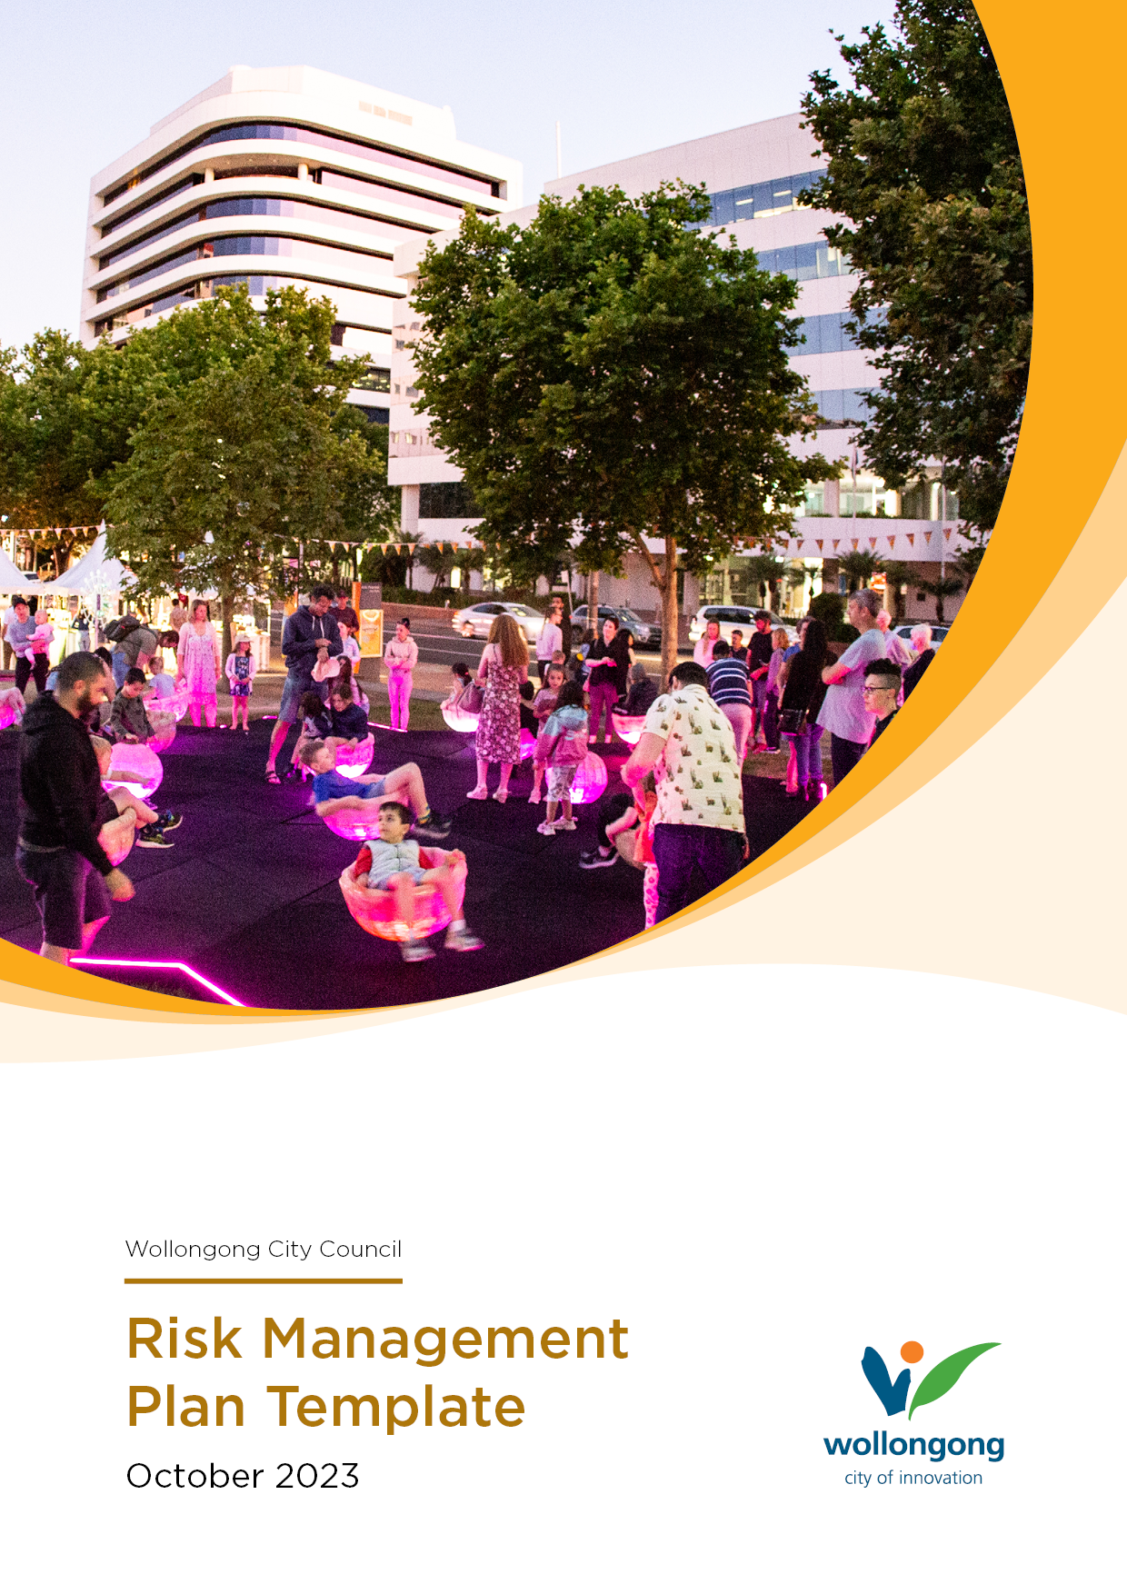
Event Risk Assessment Guide
For Small to Medium Events

Council requires that before an event is held on Council or public land an Event Plan and associated Risk Assessment is completed to support an application for relevant permits and licenses. Please note Council does not approve your Risk Assessment as it is part of your application process.
It is the organisers responsibility to provide a safe and healthy environment for those attending and working at their event. The organiser is required to undertake a risk analysis to ensure that risks specific to the event and the proposed location are identified, assessed, and controlled. The plan must include identification and measurement of the risks, together with the proposed control of those risks.
Risk Assessment Template
Council has provided a Risk Assessment Template for medium to small event to help organisers meet their requirements for approval.
This template is a general guide only and may not include all the risks and controls specific to your event.
Example risks and risk controls have been included as suggestions. Some controls may or may not be applicable to your event. You are required to add or delete controls and risks to customise the assessment to your event.
It is suggested you work through the template in a logical fashion moving from left to right considering each individual risk and completing the risk assessment for each one before moving to the next.
How to use the Template
Start by completing the information at the top of the Template.

Step 1: | Read through each individual risk and indicate if the risk is applicable to your event by choosing ‘Yes’ or ‘No’ from the drop-down box.
Step 2: | Once you identify a risk that applies to your event, conduct an assessment by using the Severity and Likelihood columns (see Risk Management Ranking Table for more information).
Step 3: | Review the example controls and remove or add specific controls that you have in place to control the risk.
Step 4: | Once controls are in place, review the level of residual risk.
Step 5: | Enter the name of the person responsible for managing the control you have identified. e.g., Event Manager, Site Manager, Volunteer, Traffic Management company etc.
Step 6: | Indicate whether the control has been implemented by choosing ‘Yes’ or ‘No’ from the drop-down box.

Complete the remainder of the risk assessment using the same process.

Risk Management Ranking Table
For Small to Medium Events

Severity Table
SEVERITY OF IMPACT
Severe  5 | Death or total permanent disability, significant environment damage, significant financial impact, state, or national media coverage
Significant  4 | Critical injury, major disruption to event, emergency services required, significant environmental impact, major financial loss, high media attention,
Moderate  3 | Medical treatment required, high financial loss, external assistance required, high numbers of public complaints, moderate environmental impact, moderate media attention
Minor  2 | First Aid required, medium financial loss, minor impact on event, low media attention, minor environmental impact
Insignificant  1 | No injuries, low financial loss, low reputational damage, insignificant environmental impact.
Likelihood Table
LIKELIHOOD OF IMPACT
Almost Certain  A | - Could happen at any time.  - Is expected to occur in most circumstances.  - Occurs annually or more frequently
Likely  B | - Will probably occur in most circumstances.  - Has occurred several times in the past (in my career)  - Might occur in a 2–3-year timeframe
Possible  C | - Has occurred once in the past.  - Might occur under normal circumstances.  - Might occur in a 5-year timeframe
Unlikely  D | - Could occur at some time.  - Could happen but unlikely.  - Might occur in a 10-year timeframe
Rare  E | - May occur in exceptional circumstances.  - Heard of something like this happening elsewhere  - Could happen but probably never will

Risk Score Matrix

LIKELIHOOD |  | SEVERITY
 |  | Severe 5 | Significant 4 | Moderate 3 | Minor 2 | Insignificant 1
Almost Certain | A | Very High 25 | Very High 20 | Very High 15 | High 10 | Medium 5
Likely | B | Very High 20 | Very High 16 | High 12 | Medium 8 | Low 4
Possible | C | Very High 15 | High 12 | Medium 9 | Medium 6 | Low 3
Unlikely | D | Very High 10 | Medium 8 | Medium 6 | Low 4 | Low 2
Rare | E | Medium 5 | Low 4 | Low 3 | Low 2 | Low 1

RISK LEVEL | ACTION YOU SHOULD TAKE
VERY HIGH  HIGH | Immediate action required; Eliminate or reduce risk; or accept risk provided residual risk level is understood
MEDIUM | Reduce risk; or accept risk provided residual risk level is understood
LOW | Accept the risk; Manage by routine procedure

