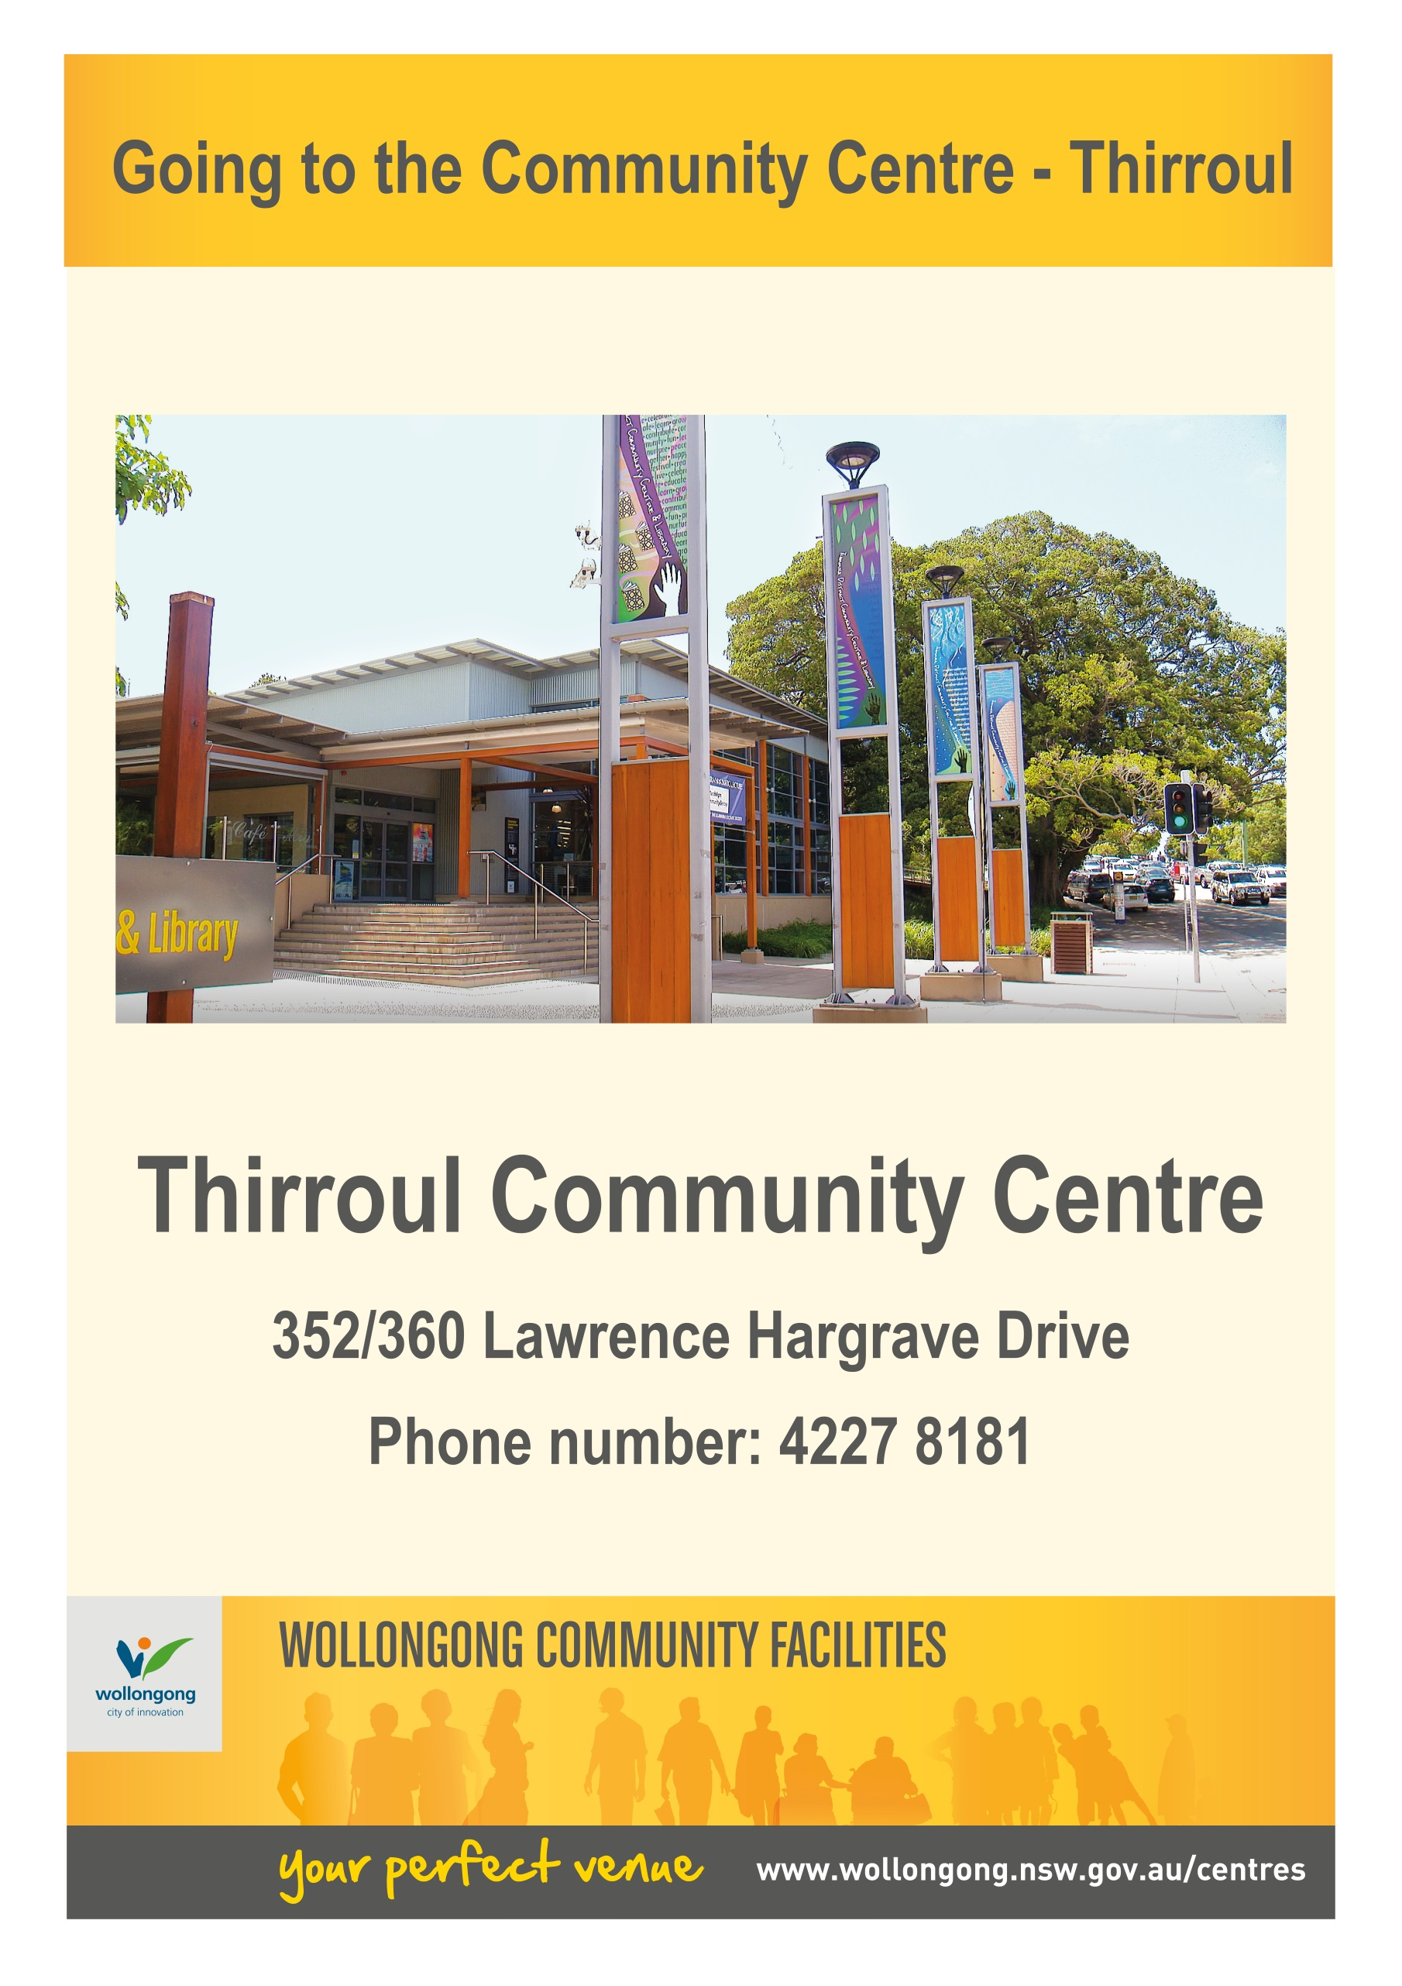

Soon, I am going to the Thirroul District Community Centre and Library.

**Going to the Community Centre - Dapto**

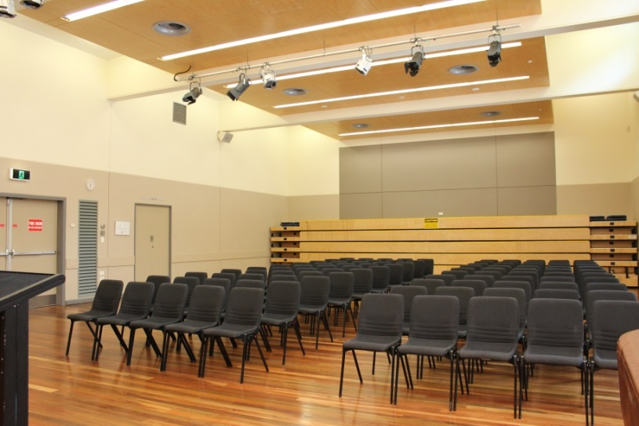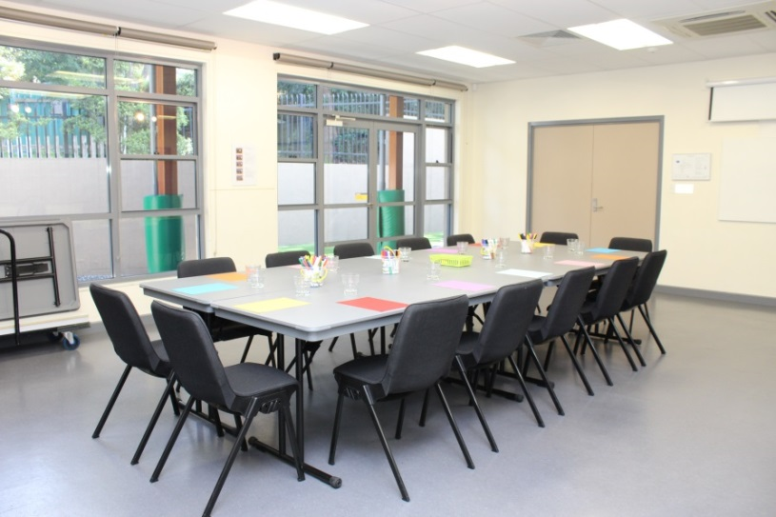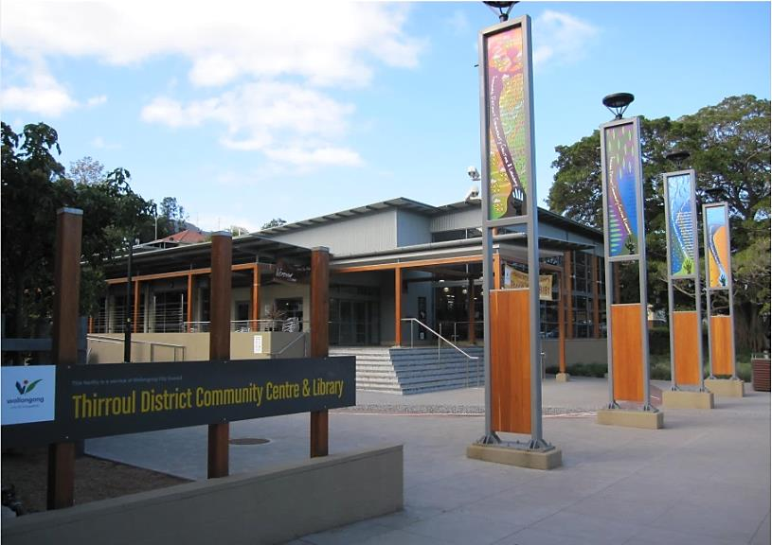

There are different rooms for learning, activities, meetings and parties. Some rooms are large and some are small.

Lots of people go to the centre from babies and families to older people.

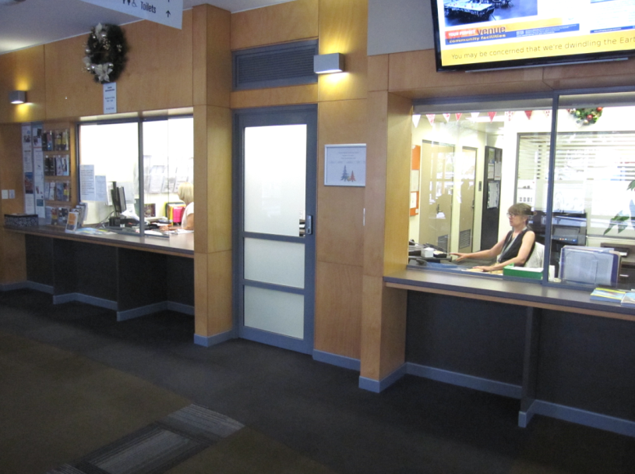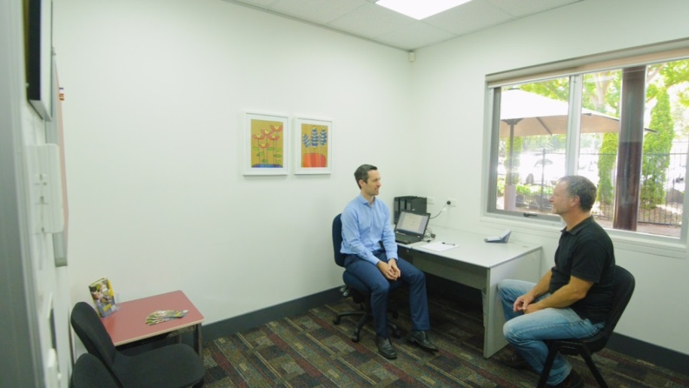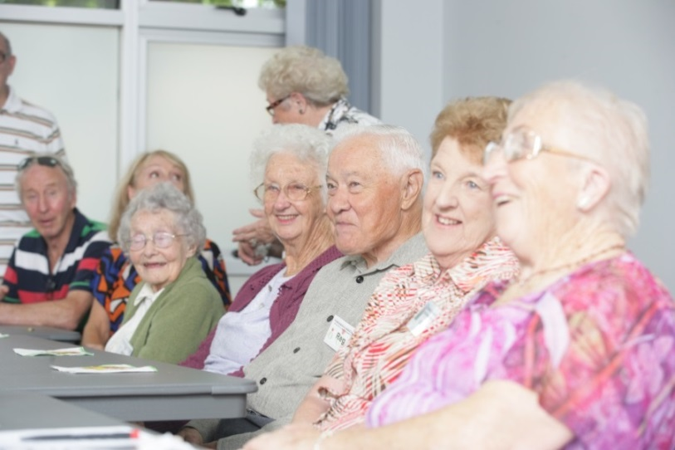

If I am lost or have a question, I can speak to the people working at the front desk. They are very nice and will help me.

People might be working or learning so I will need to use my quiet voice when I’m in the centre.   
If I need to make a small amount of noise that’s ok also.

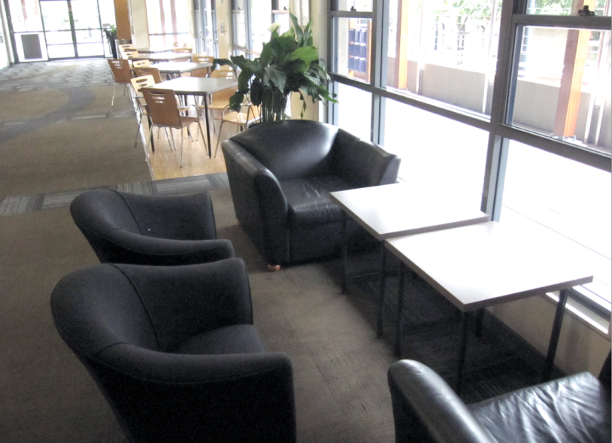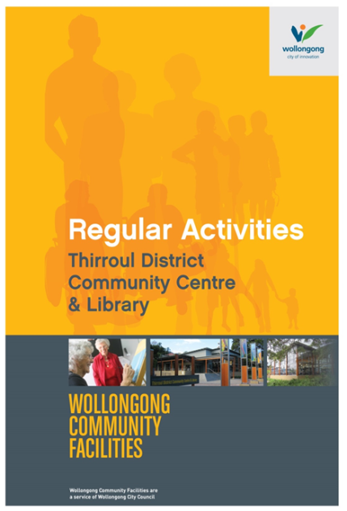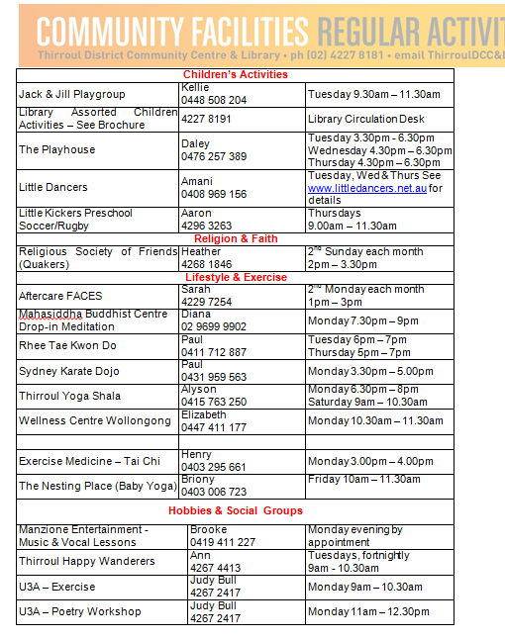

I can ask the office for a booklet to find out about different activities held at the Centre. I can take this home and call the phone numbers listed in the booklet if I want to join a group.

I can sit on the chairs when I’m waiting to go into a room or if need to have a break.

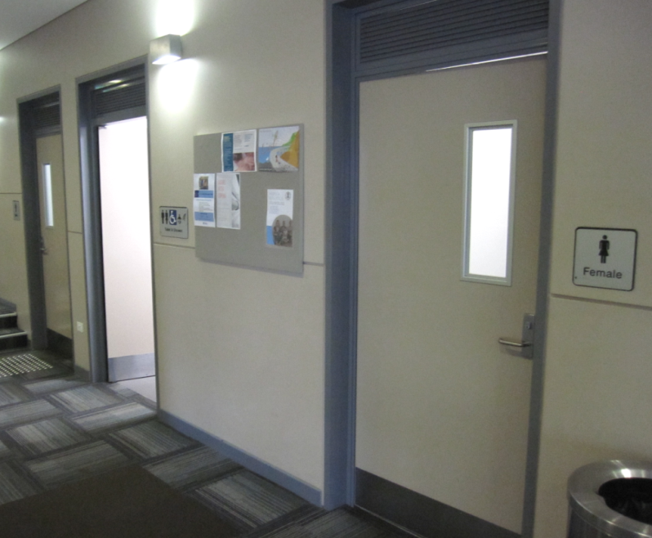[](https://www.google.com.au/url?sa=i&rct=j&q=&esrc=s&source=images&cd=&cad=rja&uact=8&ved=2ahUKEwivyODlzdzdAhUEXLwKHfQEA64QjRx6BAgBEAU&url=https://en.wikipedia.org/wiki/Moran's_I&psig=AOvVaw0mKyTROxNryIM0I3cnBMSp&ust=1538186603827848)[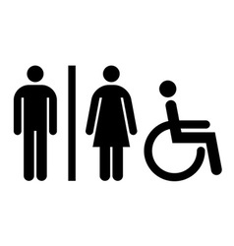](https://www.google.com.au/url?sa=i&rct=j&q=&esrc=s&source=images&cd=&cad=rja&uact=8&ved=2ahUKEwj0jJLX1KjfAhWLdH0KHdpUAyQQjRx6BAgBEAU&url=https://www.vectorstock.com/royalty-free-vectors/accessible-restroom-sign-vectors&psig=AOvVaw0XzAhO1nuSHng7z_GYDKHt&ust=1545197800010449)

There is a bathroom for me to use if I need to go to the toilet.

**FINISHED**

We look forward to seeing you at Thirroul District Community Centre and Library again soon!