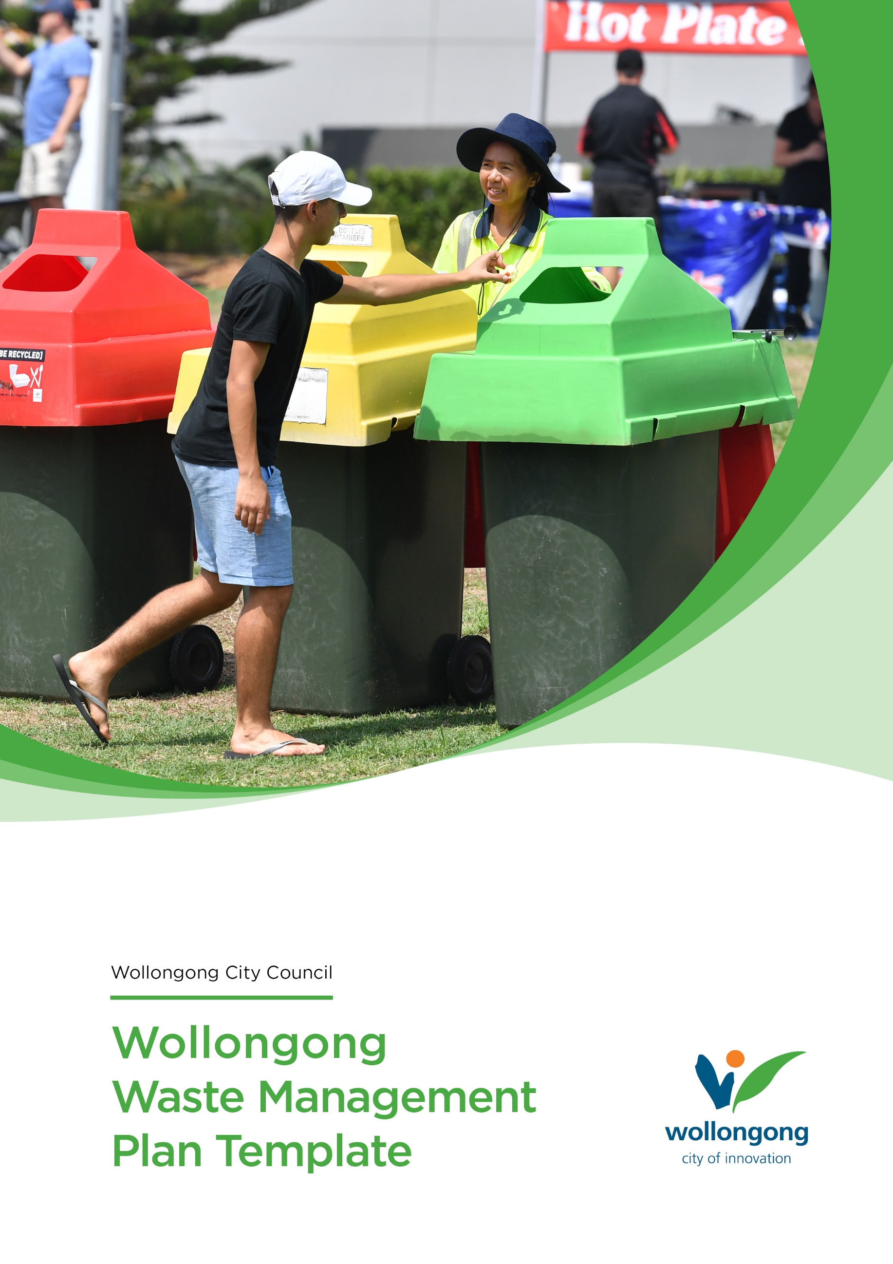

Waste Management and Minimisation Plan
Event:
Event date:
Location:
Total Estimated attendance:
- Participants (if applicable):
- Spectators (if applicable):
How many food/beverage vendors will you have at your event:

How many bins are you intending to provide at your Event?
It is up to the Event Organiser to supply bins and skips for your event and arrange collection and disposal of waste post-event. Please note Council does not supply bins or waste collection for Event Organisers.
Bin Type | Quantity
General Waste 240L wheelie bins:
Recycling 240L wheelie bins:
Organics 240L wheelie bins:

Do you require Skip Bins at your event?
If you have a significant crowds or multi-day events, you will need to arrange skip bins. Event Organisers are responsible for contacting a waste company for skip delivery and disposal.
Skip Type | Quantity
General Waste:
Recycling:
Organics:
Date of Skip Delivery:
Date of Skip Collection:

How will you manage waste removal at the end of your event?
For example – will you take waste with you or will you use a waste company to take your waste offsite post event.

Please provide a site map showing the locations for your bins and or skips.

How will participants access water at your event?
For example water stations with disposable cups, existing bubbler infrastructure, refillable bottles, other.
Events with more than 1000 attendees can apply to Sydney Water to have FREE portable water stations. See the Sydney Water fact sheet.

Sustainability and Waste Minimisation
Council encourages Event Organisers to think about Sustainability and Waste minimisation for their event. Please refer to the following
- Single Use Plastic Policy
- Sustainable Events Guide
- Sustainable Events Checklist
Please explain any practices you have in place to reduce waste and encourage sustainable at your event.

