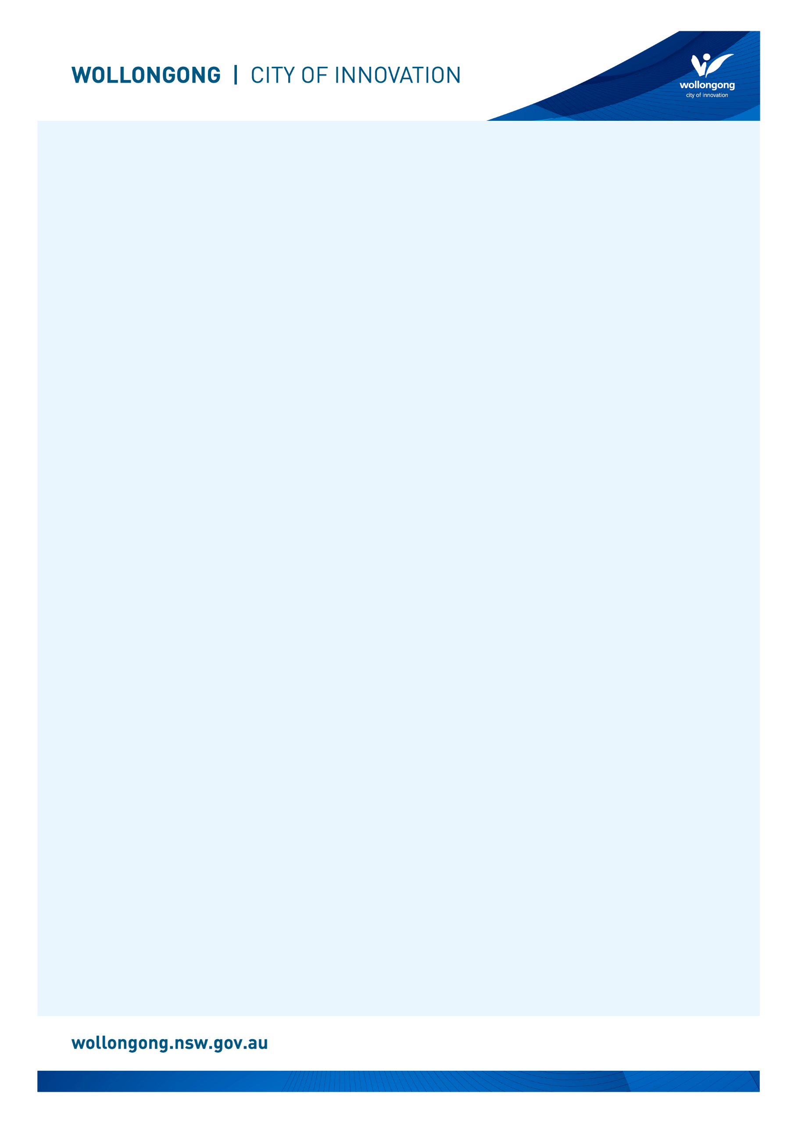

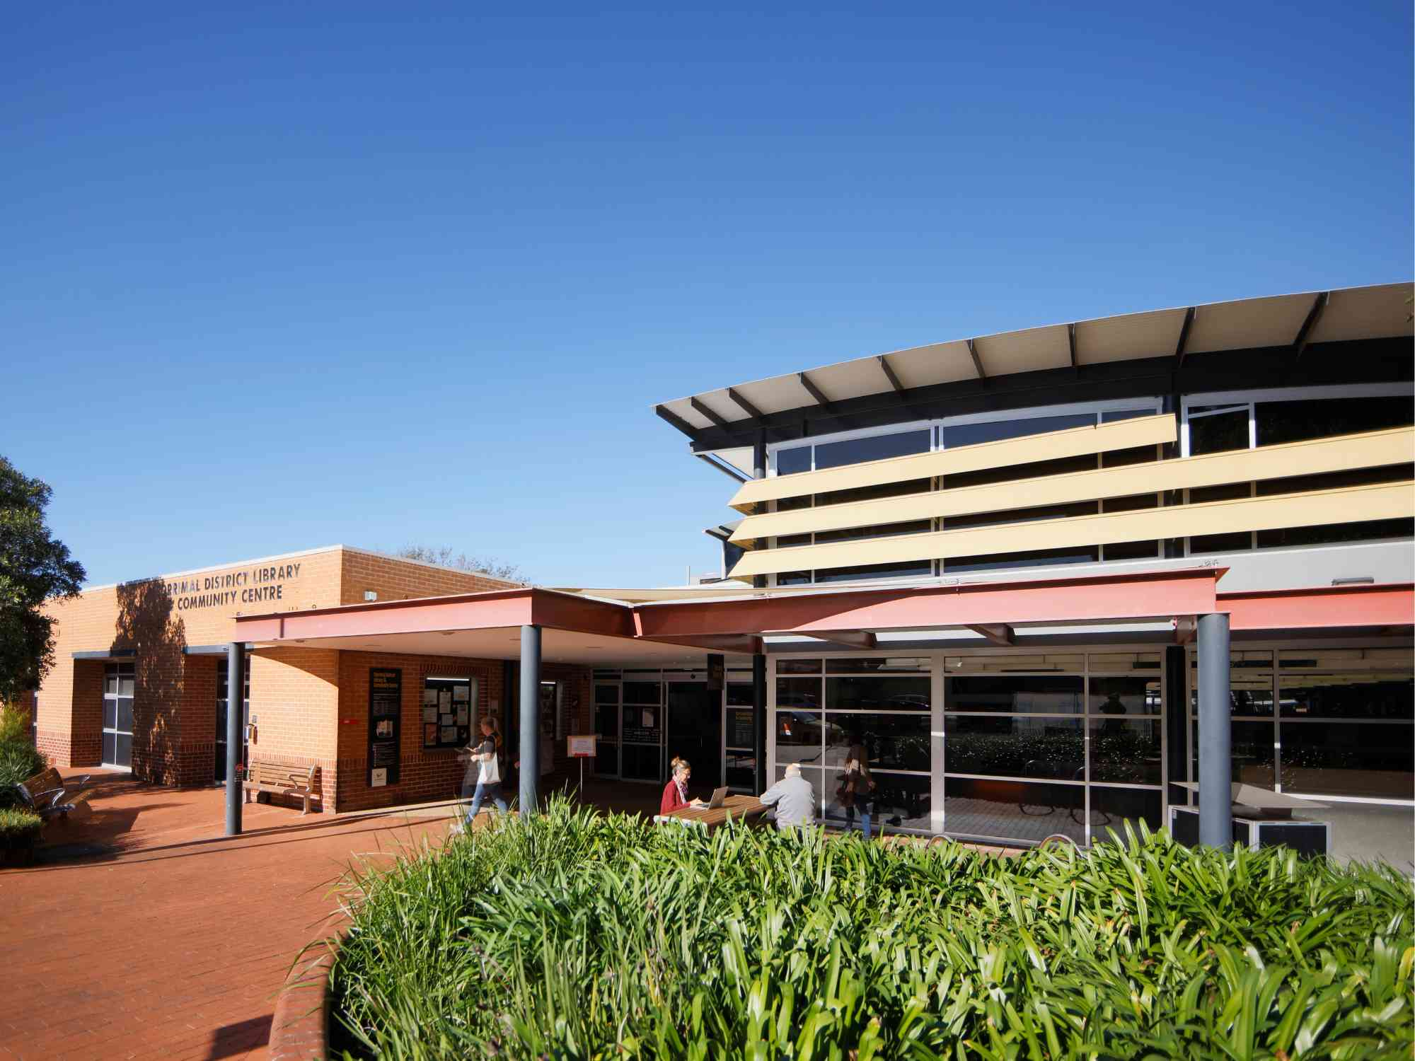

# Going to

# Corrimal Library

## Before I go to the library

|  |  |
| --- | --- |
| I’m going to Corrimal Library. | The front entry glass doors of Corrimal Community centre and Library. |
| If I am nervous about going, I can talk to someone and ask questions first. I can phone Corrimal Library on (02) 4227 8179. | A female library staff member with a brown bob talking on the phone at the library service desk. |

## About the library

|  |  |
| --- | --- |
| There are people who work at the library who I can talk to. | A staff member with short brown hair wearing red jumper is smiling while putting books back on the shelf in the library. |
| The library is usually a quiet place where people talk quietly, relax and read books. | Four upholstered armchairs face each other inside the light-filled Corrimal Library. Shelves of DVDs can be seen in the background. |
| Sometimes it might be loud. If it gets too noisy, I can ask the library staff for help. | A group of women sitting on the floor with babies inside the library. They are participating in a children's program. |
| Every week, Corrimal Library has a Quiet Hour on Thursday from 2-3pm. I can go to Quiet Hour. | An a-frame sign sits on the library floor. It reads "Quiet Hour. Every Thursday 2-3pm. We're making the library a calmer and quieter environment to support people who are neurodivergent, have heightened sensory needs, or who might otherwise benefit from a less overwhelming space. |
| During Quiet Hour, the library is calm. The lights are turned off, sounds are kept low, and people talk quietly. | Corrimal library bookshelves with lights turned off for Quiet Hour. |

## How I become a member of the library

|  |  |
| --- | --- |
| When I get to the library I will see a desk. | Corrimal Library customer service desk at the front of the library. |
| I will talk to someone who works there to become a library member. | A female library staff member with long blonde hair stands behind the Corrimal Library customer service desk and smiles into the camera. |
| I will tell them my name, address, date of birth, telephone number, and email address. | A female library staff member with a blonde bob sits at the Corrimal Library customer service desk and uses a computer. |
| I will need to bring one form of identification with my name and address, such as a driver’s licence or concession card. | A graphic representation of a blue and white ID card. |
| I'll answer some questions and learn about borrowing. I will receive a library card, and this makes me a library member. | Four Wollongong City Libraries' library cards, in the colours gold, orange, blue and pink. |

## When I visit the library

|  |  |
| --- | --- |
| In the library there will be shelves of books, CDs, DVDs, and magazines. | A shelf of books in Corrimal Library |
| I can sit in a chair to read a book. | A blonde woman sitting on a green chair reading a book. Shelves of CDs can be seen behind her. |
| I can borrow a book, CD, DVD, or magazine and take it home with me for four weeks. | A man and woman looking at books on a library shelf. |
| If I want to borrow a book, CD, DVD, or magazine I will talk to a library staff member. | A young woman talks with a library staff member about a book they are holding. |
| The staff will show me how to borrow the book, CD, DVD, or magazine and tell me when I need to bring it back to the library. | A young girl borrows a book on the Corrimal Library self-checkout machine. |
| The library will also have some computers. | A row of public computers in Corrimal Library. |
| The computers are free to use with my library card. | A woman sitting at a public computer desk in Corrimal Library. |
| One of the computers has a Vision Australia keyboard for people with low vision. | A public computer monitor with a mouse and a yellow and black Vision Australia keyboard. |
| The library has some sensory tools I can borrow when I am in the library. I can ask a library staff member to borrow sensory tools. | A plastic tub sitting on a desk with a label that reads "Sensory Kit (Corrimal Library)" and a list of items contained within the tub. |
| I can use the bathroom just outside the library in the community centre. | A long shot of a hallway in Corrimal Community Centre with public bathroom doors. |
| When I have finished, I will leave the library through the main door. | Corrimal Library glass sliding main entry door. |
| I’ll come back to my library to return the things I borrowed and find new things to take home! | A metal box with handle built into a brick wall -Corrimal Library external returns chute. |
| I can use the return chute outside or inside my library to return what I borrowed. | A window about a metal shelf - Corrimal Library's internal returns chute. |

We look forward to seeing you at Corrimal Library again soon!

[](https://www.google.com.au/url?sa=i&rct=j&q=&esrc=s&source=images&cd=&cad=rja&uact=8&ved=2ahUKEwivyODlzdzdAhUEXLwKHfQEA64QjRx6BAgBEAU&url=https://en.wikipedia.org/wiki/Moran's_I&psig=AOvVaw0mKyTROxNryIM0I3cnBMSp&ust=1538186603827848)

**FINISHED**