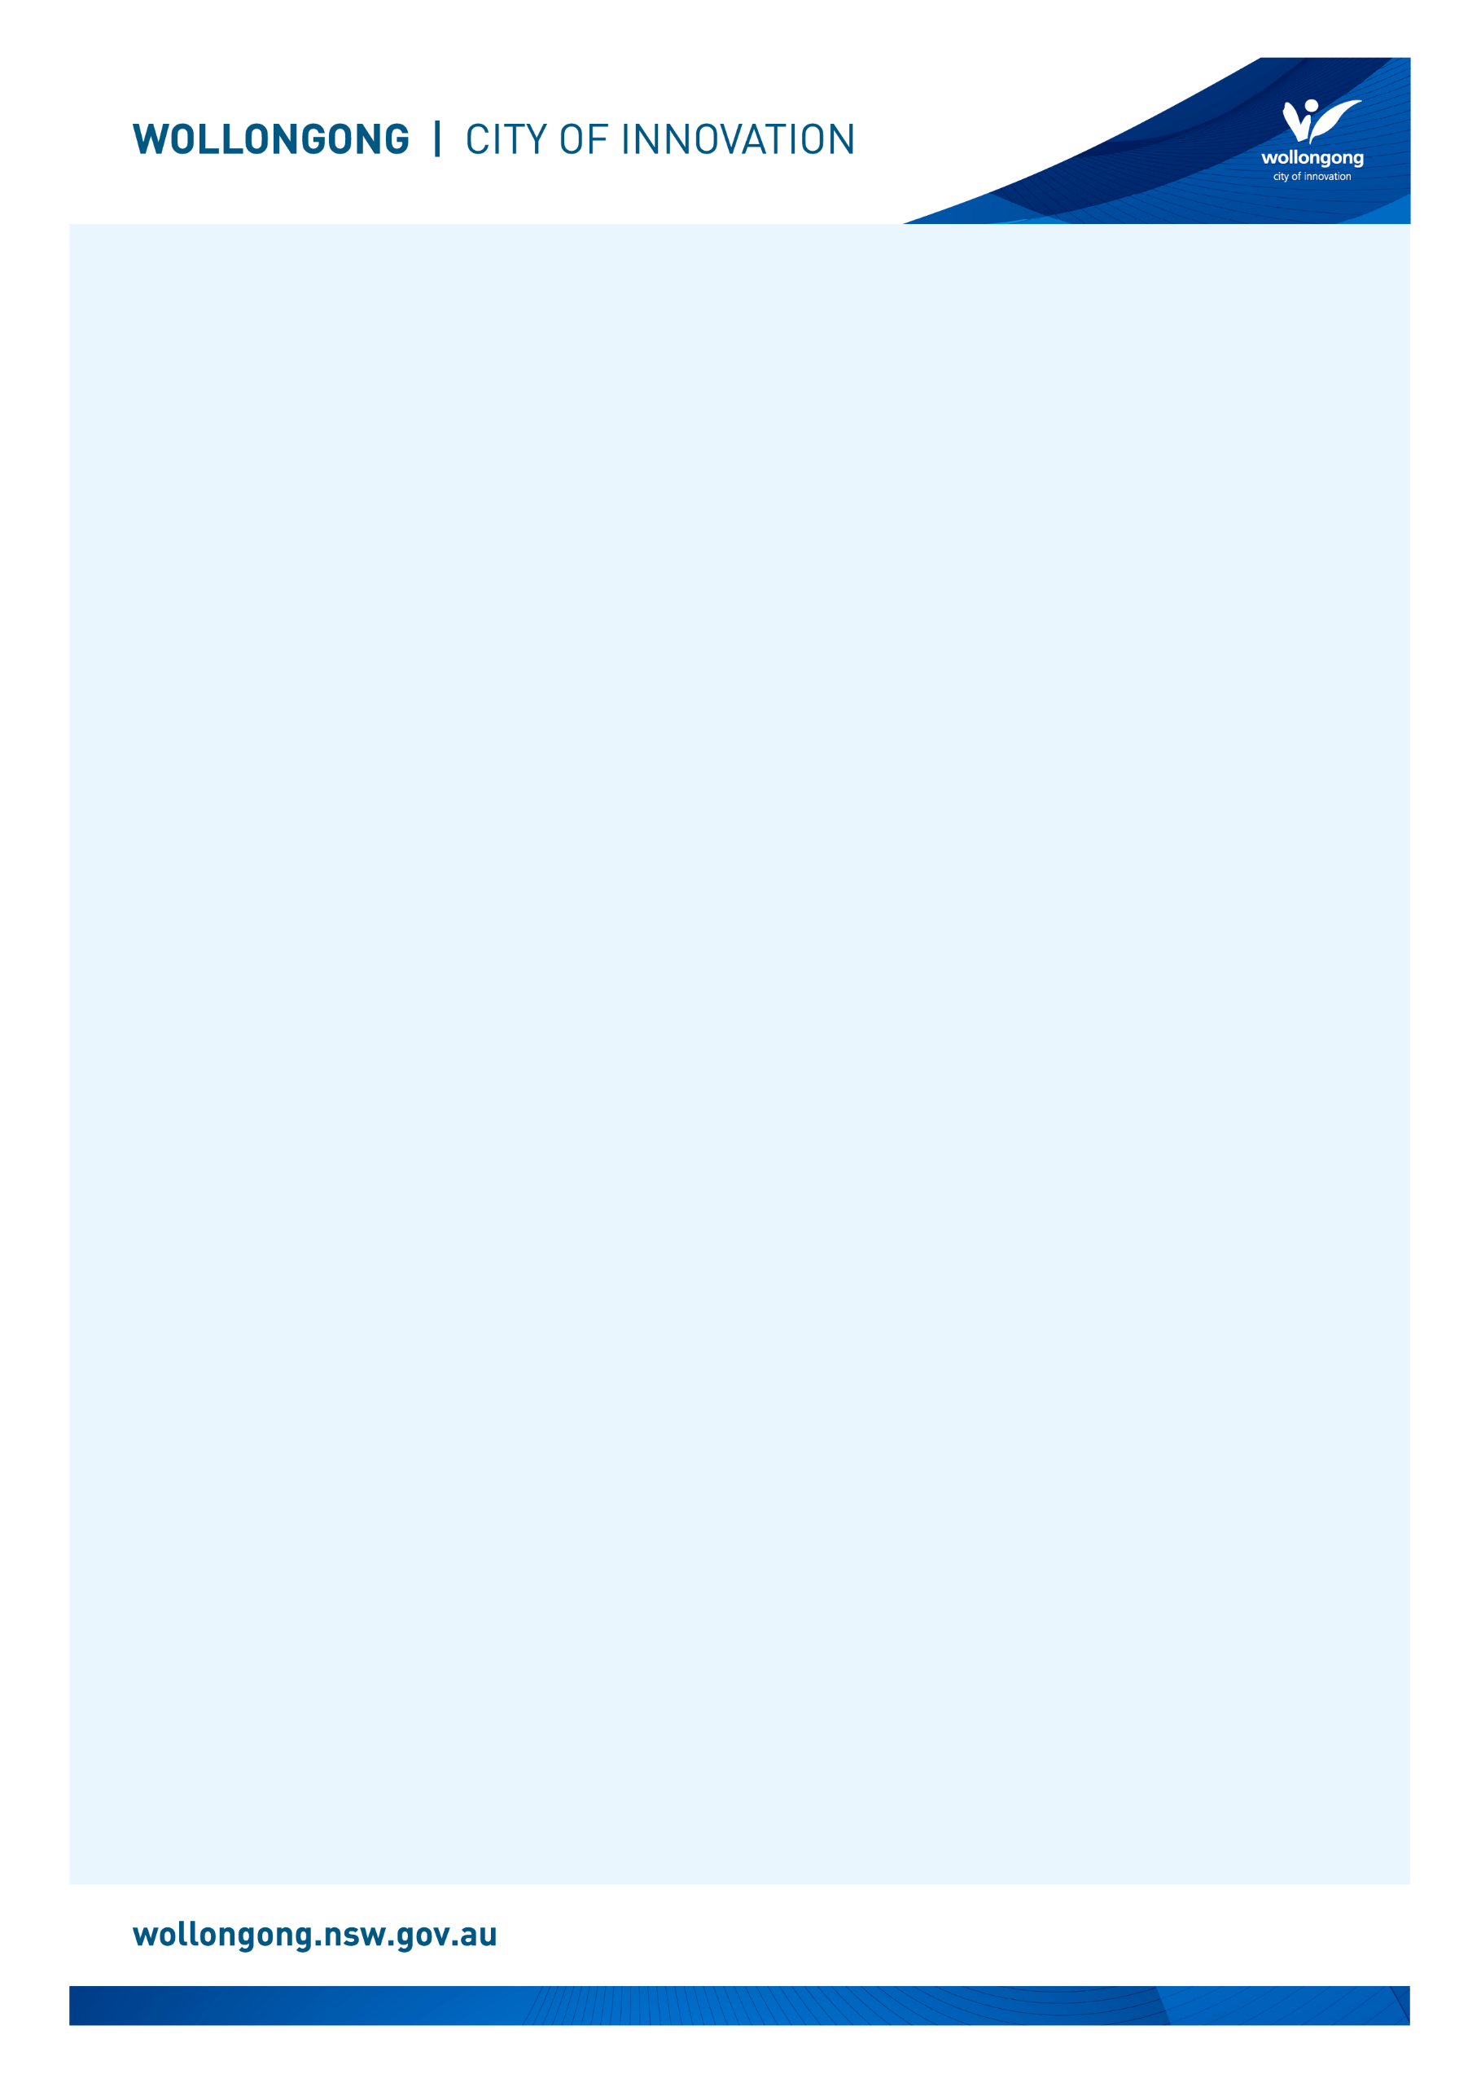

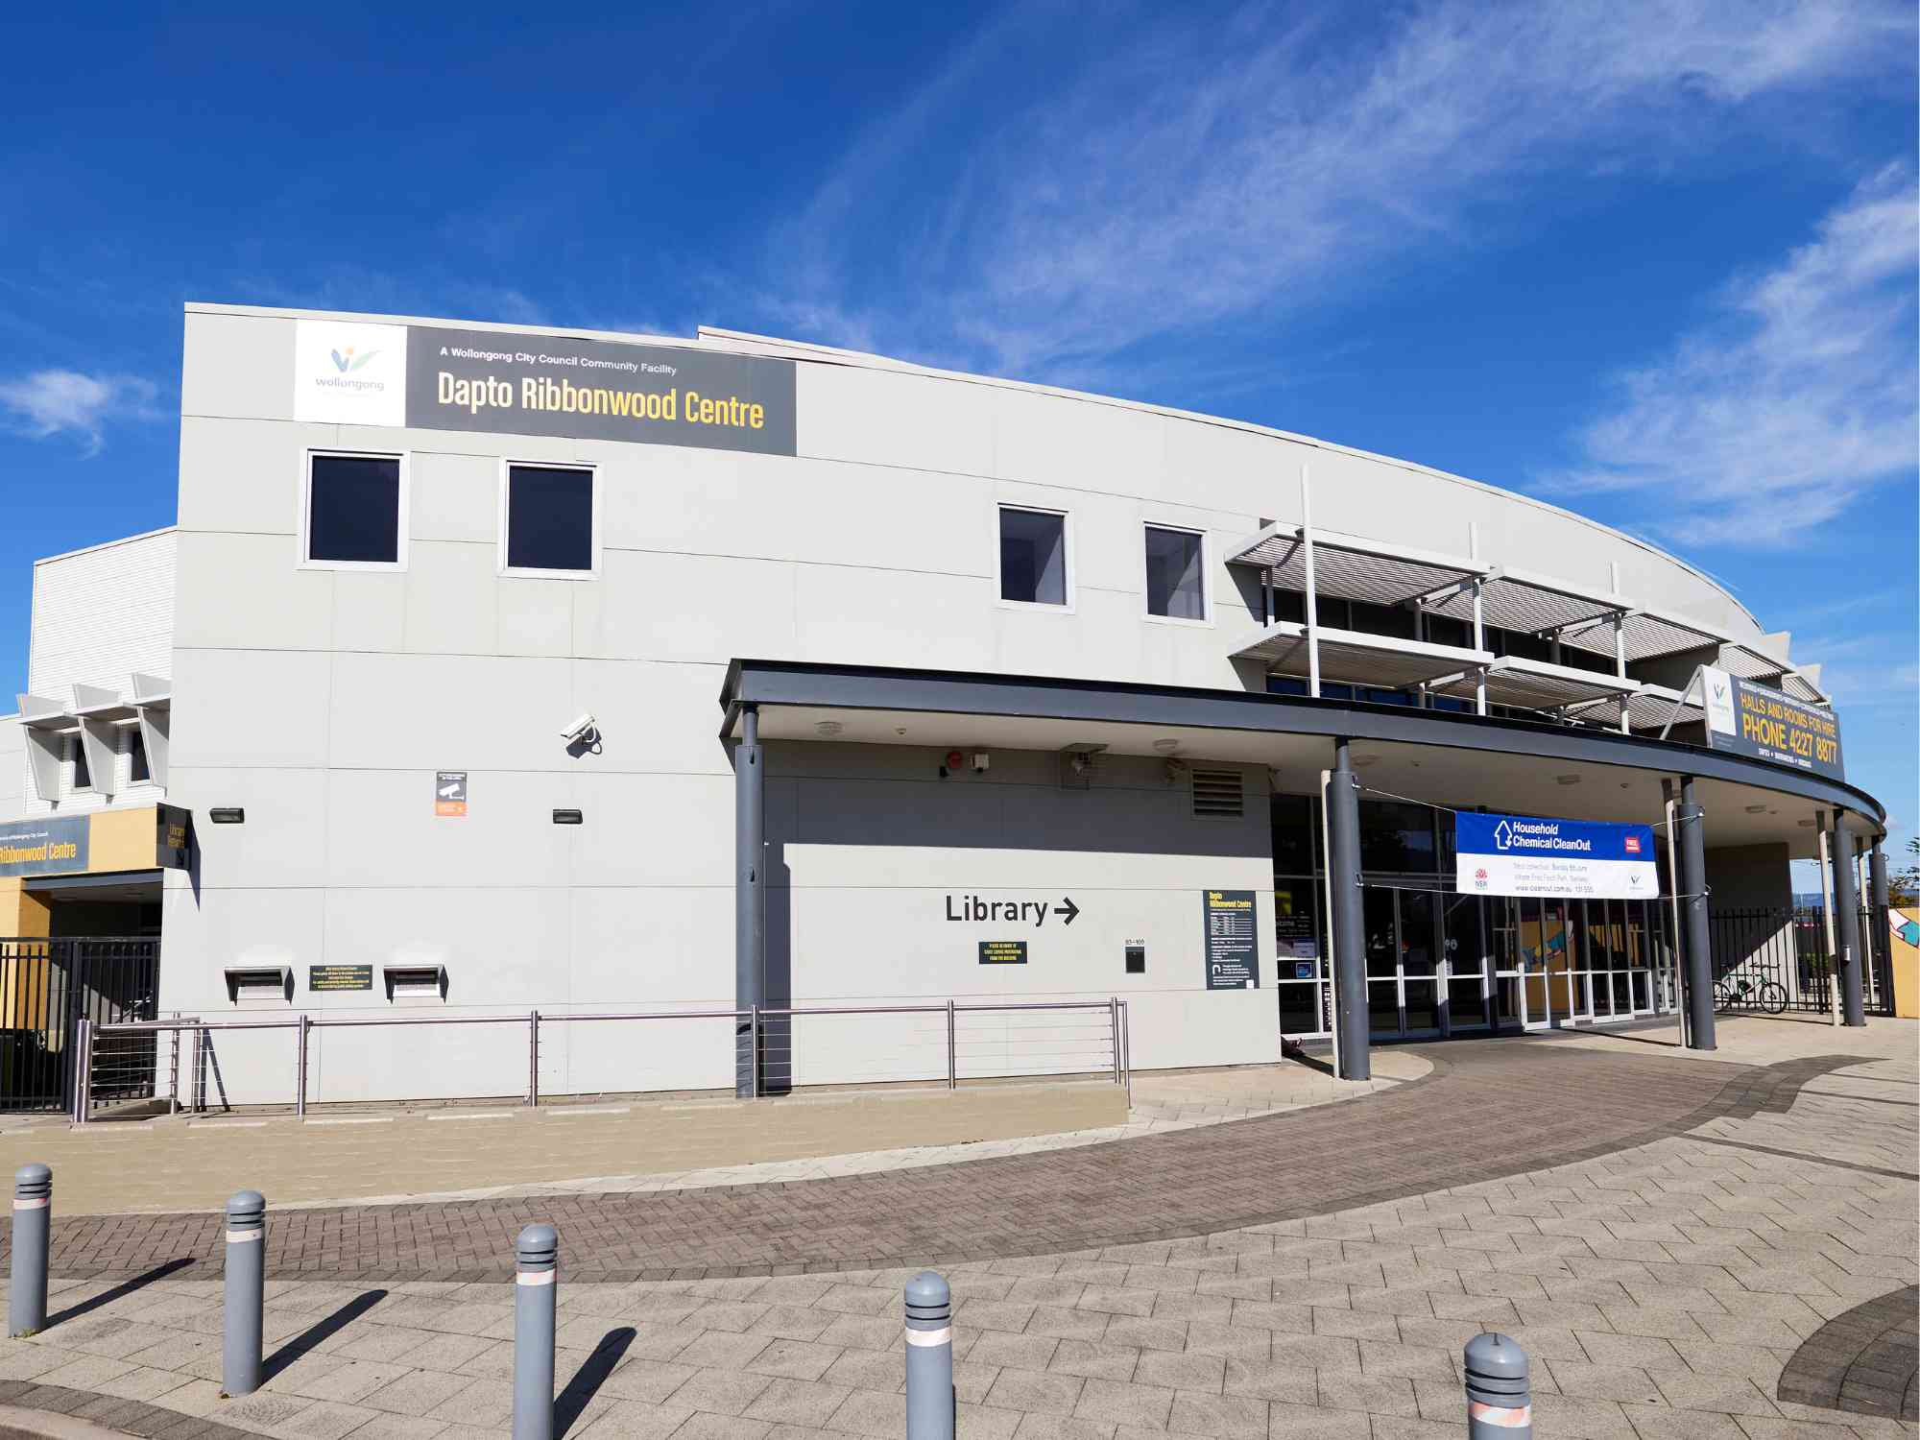

# Going to

# Dapto Library

## Before I go to the library

|  |  |
| --- | --- |
| I’m going to Dapto Library. | The front entry glass doors of Dapto Ribbonwood Centre and Library. |
| If I am nervous about going, I can talk to someone and ask questions first. I can phone Dapto Library on (02) 4227 8555. | A female library staff member talking on the phone. |

## About the library

|  |  |
| --- | --- |
| There are people who work at the library who I can talk to. | A female librarian with brown hair and glasses is smiling while putting books back on the shelf in the library. |
| The library is usually a quiet place where people talk quietly, relax and read books. | Two upholstered armchairs face each other inside Dapto Library. Shelves of DVDs can be seen in the background. |
| Sometimes it might be loud. If it gets too noisy, I can ask the library staff for help. | A male librarian reading a picture book to of a group of parents with their children. They are participating in a children's program. |

## How I become a member of the library

|  |  |
| --- | --- |
| When I get to the library I will see a desk. | Dapto Library customer service desk at the front of the library. |
| I will talk to someone who works there to become a library member. | A female customer with brown hair is at the Dapto Library desk where a librarian is standing at a computer to sign the customer up as a member. |
| I will tell them my name, address, date of birth, telephone number, and email address. | A female customer with brown hair is at the Dapto Library desk where a librarian is standing at a computer to sign the customer up as a member. The customer is holding up an orange library card in their hand. |
| I will need to bring one form of identification with my name and address, such as a driver’s licence or concession card. | A graphic representation of a blue and white ID card. |
| I'll answer some questions and learn about borrowing. I will receive a library card, and this makes me a library member. | Four Wollongong City Libraries' library cards, in the colours gold, orange, blue and pink. |

## When I visit the library

|  |  |
| --- | --- |
| In the library there will be shelves of books, CDs, DVDs, and magazines. | A row of shelves with books in Dapto Library. |
| I can sit in a chair to read a book. | A woman with blonde hair is sitting on a chair at Dapto Library reading a book. |
| I can borrow a book, CD, DVD, or magazine and take it home with me for four weeks. | A woman with blonde hair wearing a blue shirt is browsing the CD's on s shelf at Dapto Library. |
| If I want to borrow a book, CD, DVD, or magazine I will talk to a library staff member. | A library staff member is smiling with a pile of children's picture books at the Dapto Library front desk. |
| The staff will show me how to borrow the book, CD, DVD, or magazine and tell me when I need to bring it back to the library. | A customer is holding out their card to use the self-checker machine at Dapto Library. |
| The library will also have some computers. | Two public computers at Dapto Library. |
| The computers are free to use with my library card. | A customer with blonde hair is typing on the keyboard at a computer at Dapto Library. |
| One of the computers has a Vision Australia keyboard for people with low vision. | A Vision Australia keyboard at a Dapto Library computer which has very large black text on yellow keys to help people with low vision. |
| The library has some sensory tools I can borrow when I am in the library. I can ask a library staff member to borrow sensory tools. | A pile of sensory tools including headphones, two tangle fidgets, liquid motion sand timer, a silicone pop ball and a plush turtle. |
| I can use the bathroom at the front of the library, near the entrance. | The door to the bathroom near the front entrance of Dapto Library. |
| When I have finished, I will leave the library. I’ll come back to my library to return the things I borrowed and find new things to take home! | Dapto Library main glass sliding entry and exit door. |
| I can use the return chute outside or inside my library to return what I borrowed. | Dapto Library external returns chute which is a metal box with handle built into an external grey wall. |

We look forward to seeing you at Dapto Library again soon!

[](https://www.google.com.au/url?sa=i&rct=j&q=&esrc=s&source=images&cd=&cad=rja&uact=8&ved=2ahUKEwivyODlzdzdAhUEXLwKHfQEA64QjRx6BAgBEAU&url=https://en.wikipedia.org/wiki/Moran's_I&psig=AOvVaw0mKyTROxNryIM0I3cnBMSp&ust=1538186603827848)

**FINISHED**