Neighbourhood Forum 5  Wollongong’s Heartland | 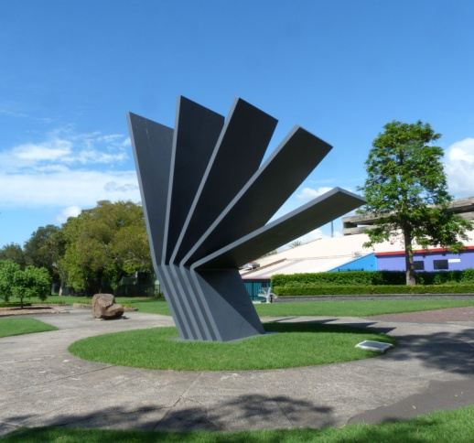 | Coniston, Figtree, Gwynneville, Keiraville, Mangerton, Mount Keira, Mount St Thomas, North Wollongong, West Wollongong, Wollongong City.

Minutes of meeting at 7.00 pm Wed. 2nd October 2019 in the Town Hall Ocean Room

Present 18 members and Acting Lord Mayor Tania Brown.

1 Presentation David Winterbottom was thanked for his presentation on Medium Density Development.
It was resolved that his notes be distributed with the minutes.

2 Apologies were accepted.

3 Minutes of meeting of 4th September were adopted with no matters arising.

4 Comments Cllr Tania Brown reported on the World Cycling Event in 2022; the need to upgrade the WIN Stadium; and that Council's Emissions targets are to go on exhibition.

Clare Rhodes re-iterated the invitations mentioned in the agenda. Guests can register for the Wollongong Campus Tour online or view other activities on our Events calendar.

Residents opposed to the Murphys Avenue townhouses spoke of their concerns.
It was agreed that Council be requested to ensure that any revised proposal was put on public exhibition, together with correct technical assessments, given serious concerns about:
1 the advice being proffered on DA's in relation to flooding, is such that a moratorium on development in flood plains should be imposed until revised Studies have been completed;
2 the advice being proffered on DA's in relation to traffic and parking, specifically in relation to development west of Robsons Road;
3 The dangerous traffic situation on Robsons Road;
4 the advice being proffered on DA's in relation on-site traffic movement, specifically turning circles;

Current active membership of Neighbourhood Forum 5 : 398 households

5 the advice being proffered on DA's in relation to the assessment of local character, which flies in the face of any rational interpretation;
6 tree removals and landscaping;
7 the protocols and attitude of the Wollongong Local Planning Panel in relation to community presentations.

It was also agreed to seek urgent meetings with the Director of Infrastructure + Works and with the Director of Planning + Environment to discuss the situation.

5 Responses Crown Street Markets: noted.

Trees under Power Lines
It was agreed to defer consideration on this to the November meeting.

Council Website Improvements
It was agreed to ask Council when improvements to the Development Application components of the website will be available.

Commercial Use of Public Parks
It was agreed to request Council to ensure events are notified publically and to require a Community Impact Statement to be provided for events on public land.

6 Reports Deputy Lord Mayor
It was agreed to congratulate Tania Brown on her election as Deputy Lord Mayor.

Wollongong Director of Planning and Environment
It was agreed that Linda Davis be congratulated on her appointment and invited to address the Forum early in the new year.

draft Community Participation Plan
It was agreed to adopt as policy and make a submission to Council on their Community Participation Plan that it should:
1 require major developments to be the subject of consultation at an early stage, perhaps a public meeting or a presentation to the relevant Neighbourhood Forum;
2 require a similar process when considering Planning Proposals or Planning Agreements;
3 require all developments to be discussed with any immediately adjacent householders before lodgement;
4 require application of the Community Engagement Policy principles when determining the level of notification, based on the possible environmental and social impacts of the proposal;
5 include opportunities for mediation and alternative dispute resolution in contentious or complex situations;
6 require Council to review the description of the actual proposal rather than rely on that of the proponent, as this is sometimes misleading;
7 ensure user friendly access to information on Council's web site.
8 include a reference to the free "Planning Alerts" web site which enables residents to be notified automatically when a Development Application is lodged within a nominated distance of their property (contact@planningalerts.org.au to sign up).

Senior Citizens Centre, Gwynneville: noted

The NSW Government’s Your Council website: noted

On Call Cleanup Service for Multi Unit Dwelling; noted

7 Activities Projects: noted

Neighbourhood Forums Alliance: noted

University Liaison: noted

8 Planning DA/2019/874 Four semi-detached units, 6 Bulwarra St Keiraville
It was agreed that the submission of objection be endorsed.
DA/2019/922 Three attached houses, 147 Gipps Road Keiraville
It was agreed that a submission of objection be lodged.
DA/2019/1008 eight storey building, 1 Smith St Wollongong
It was agreed that a submission of support be lodged subject to all site disturbance being supervised by a qualified archaeologist.
DA/2019/980 Two units in a 4 storey Building, 82A Cliff Road Wg
It was agreed that a submission of strong objection be lodged.

9 General/Late Wollongong Local Planning Panel: Noted in 4 above.
Business
Parking at Beaton Park: noted

Flood Control Infrastructure
Concern was raised at the lack of funding for flood control infrastructure.
It was agreed to defer this issue for a report to the next meeting.

10 Snippets noted.

Next Meeting: 7.00 pm on Wed. 6th November 2019, Town Hall Ocean Room.

Medium Density - the Next Steps

Context
Medium density is permitted in all Residential zones.
It is restricted to lots over a minimum width.
Most wider lots are in remote areas far from services.
The Government now proposes a Code which allows Certifiers to approve low rise medium
density housing development anywhere.
Development has to meet a very complicated Code requirements but it includes subjective
issues like design and character assessment.
The Code has no proper researched justification.

The Minister
Wants the planning system to be based on what we want for the future.
Not on what we want to stop being built.
Has called for planners and the community to work together to create great places.
These to be based on the presumption in favour of sustainable development.
Has exempted Wollongong from a mandatory imposition of the Code.
Provided, by July 2020, they change their LEPs and DCPs

The Constraints
The Department of Planning Industry and Environment has policies.
These are "one control fits all" and prohibit reducing residential densities.
This is regardless of the sustainability consequences.
DCPs, controlled by Council, are advisory not mandatory.
LEPs require Ministerial (ie DoPIE) approval.
The Medium Density Development Code will over-ride all Council Controls
including the much vaunted Local Strategic Planning Statement

The Code
Specifies dimensions for "well designed" dual occupancies, manor houses and terraces
including a 2stories maximum height.
Lets them be approved by Certified Compliers, who are commissioned by the applicants,
so objective assessments evaporate.
In most cases the Code is not as strict as current controls.
But only one parking space per dwelling is required.
It does not require notification, so the community is hamstrung.
Moreover, it still has one or two mutually unattainable controls.
Council planners have reviewed the Code in detail.

The Objectives
To concentrate medium density development near local centres.
To ensure medium density elsewhere fits the character of the area.
To avoid transgressing DoPIE policies.
To harmonise the LEP and DCP provisions.
To avoid the Medium Density Code being mandated for Wollongong.

The LEP Opportunities
Require proposals to achieve the desired future character of area.
Reduce the residential site width requirements in areas of transition which we and the
Neighbourhood Forums' Alliance have already defined.
Increase site width requirements for other areas
Require all proposals to be discussed with owners of the immediately adjoining properties
before lodgement of the proposal.
Adopt most of the Exemption components of the Code

The DCP Opportunities
Review the desired future character statements.
Identify areas of transition where medium density is to be encouraged.
Develop character statements for these areas.
Elsewhere the desired future character is the appearance and ambience of dwelling houses.
That is not to exclude medium density development but to ensure that it conforms to the
streetscape and intensity of development in the area.

The Administration
Adopt the Code in an amended form in the LEP and exclude increasing Certification for
Complying Development.
Introduce a "fast track" category for applications meeting Code requirements.
Check all immediately adjacent owners have been advised of proposals.
Exclude "fast track" if neighbours object.
Allow time for objectors to make submissions.
Ensure notification reflects the potential impact of proposals.

The Recommendations
That, following debate, the issue of Medium Density Development
and potential changes to the LEP and DCP
be discussed with Council officers
Preferably in association with the Neighbourhood Forums' Alliance

