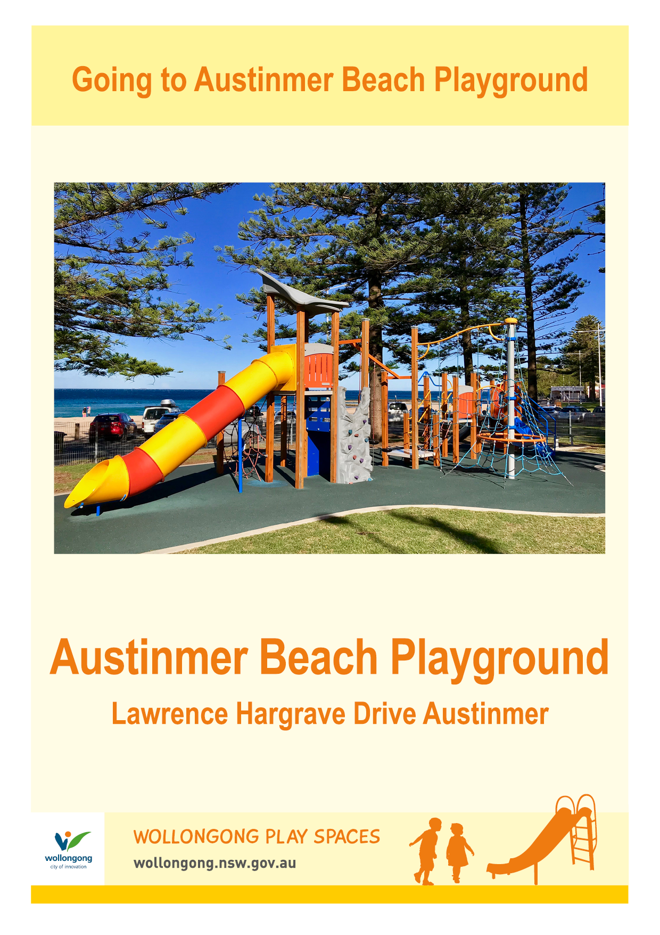

Today we are going to Austinmer Beach Playground.

**Going to the Community Centre - Dapto**

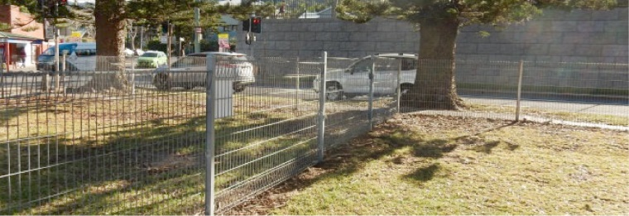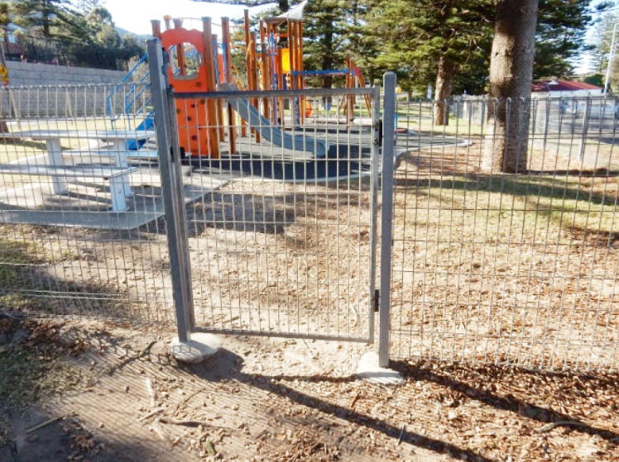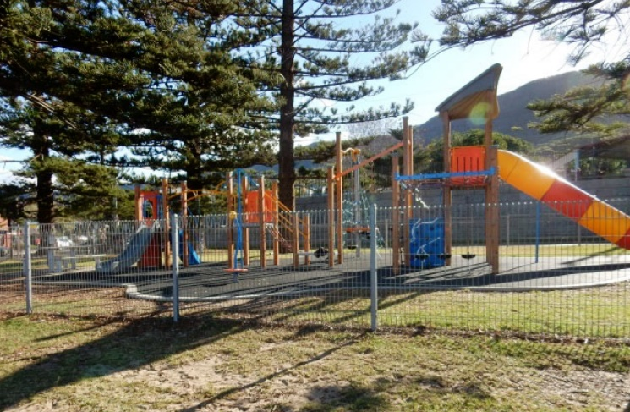

Austinmer Beach Playground has a fence to keep me safe.

I will let my parent or carer open the gate.

I can use the communication board to let people know what I would like to do while I am at Austinmer Beach Playground.

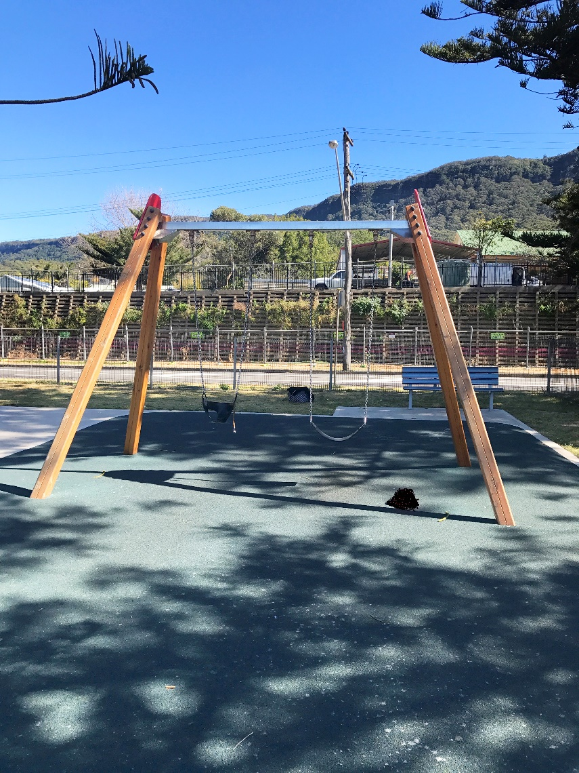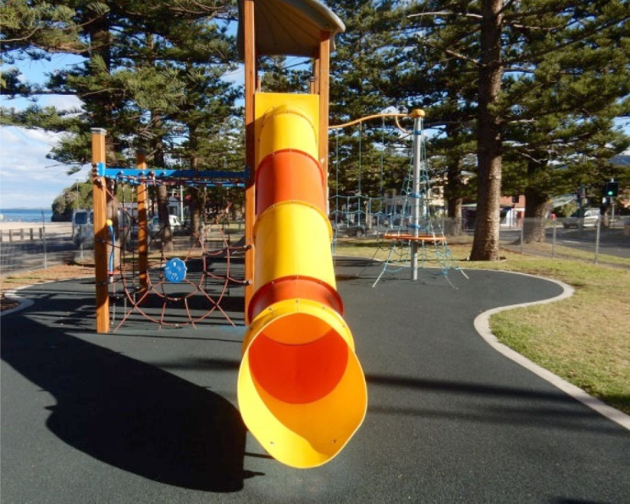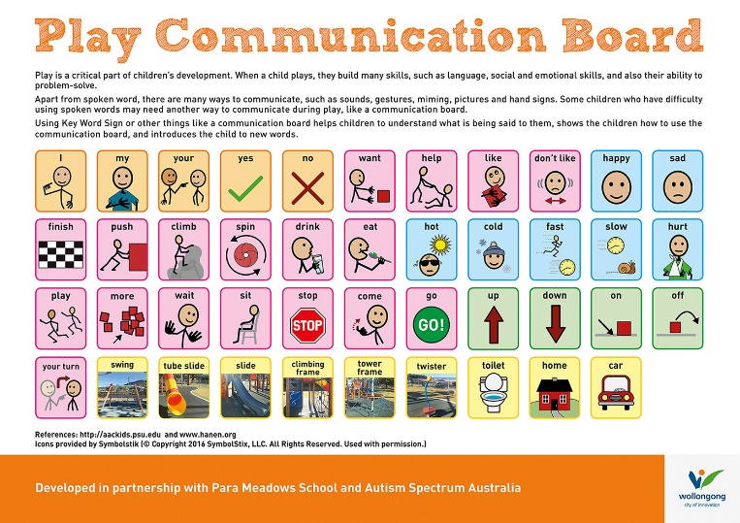

I can swing on the swings.

There are lots of fun things to do at Austinmer Beach Playground. I can play on the slide.

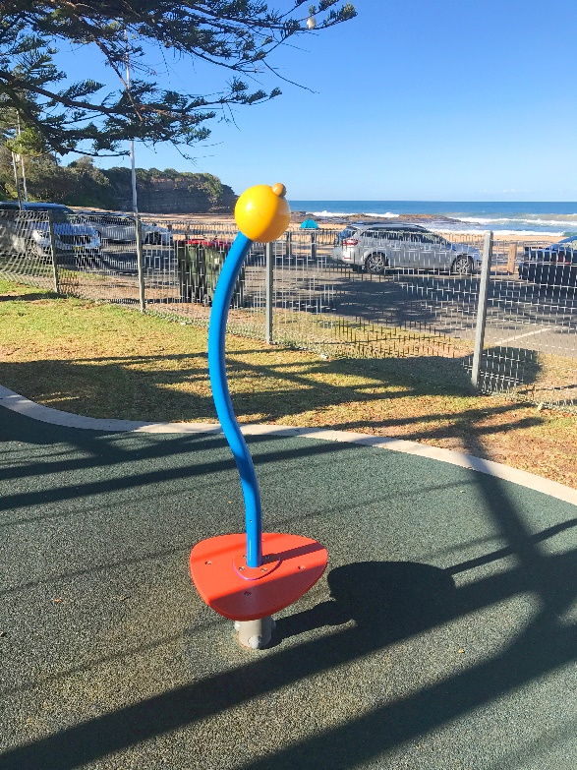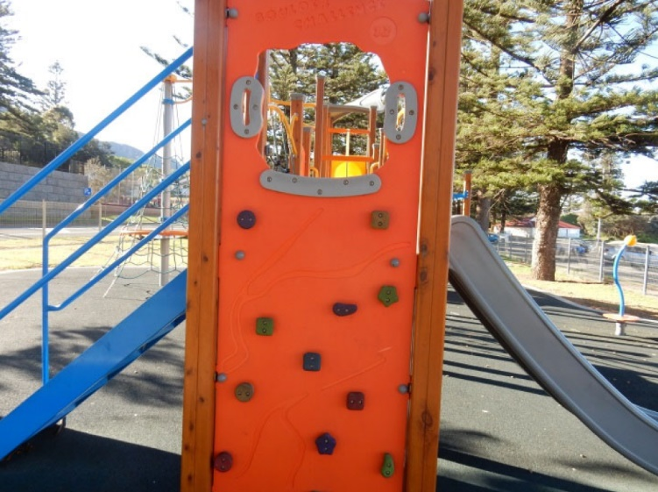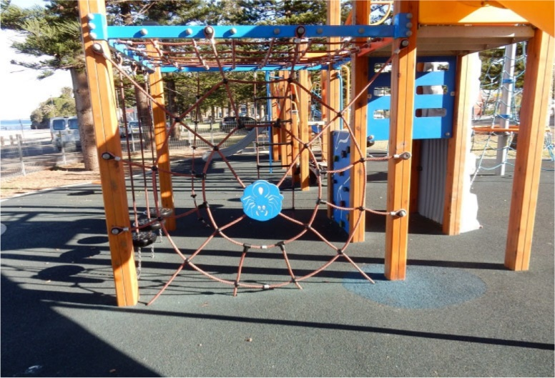

I can climb the rock wall.

I can play spin myself around.

I can climb.

I can climb the stepping stones.

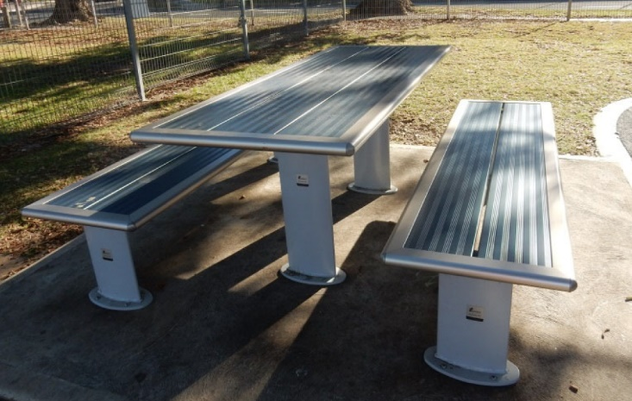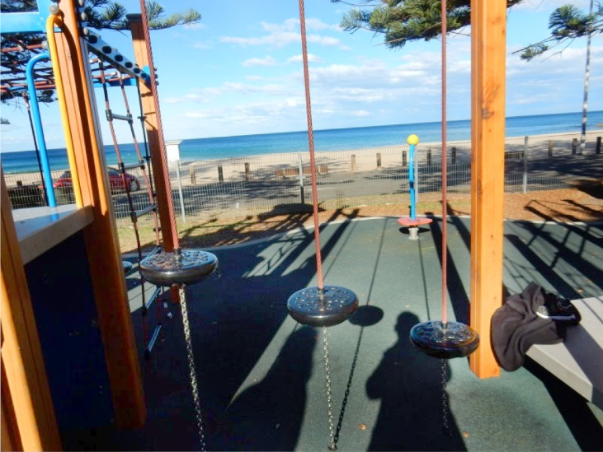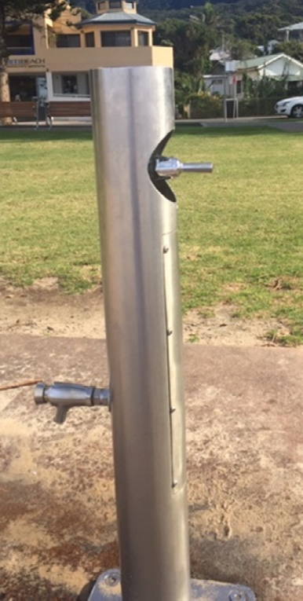

I can have a drink from the bubbler.

There is a table and chairs to rest or eat.

[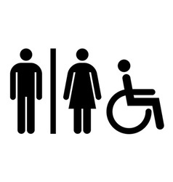](https://www.google.com.au/url?sa=i&rct=j&q=&esrc=s&source=images&cd=&cad=rja&uact=8&ved=2ahUKEwj0jJLX1KjfAhWLdH0KHdpUAyQQjRx6BAgBEAU&url=https://www.vectorstock.com/royalty-free-vectors/accessible-restroom-sign-vectors&psig=AOvVaw0XzAhO1nuSHng7z_GYDKHt&ust=1545197800010449)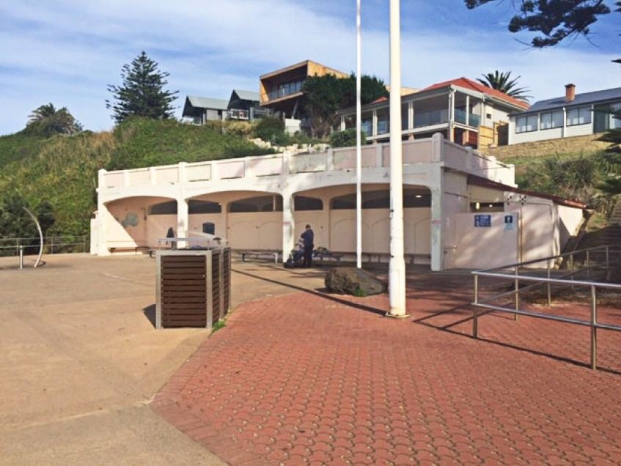[](https://www.google.com.au/url?sa=i&rct=j&q=&esrc=s&source=images&cd=&cad=rja&uact=8&ved=2ahUKEwivyODlzdzdAhUEXLwKHfQEA64QjRx6BAgBEAU&url=https://en.wikipedia.org/wiki/Moran's_I&psig=AOvVaw0mKyTROxNryIM0I3cnBMSp&ust=1538186603827848)

We hope you had a great time at Austinmer Beach Playground!

I can walk up the path towards the Surf Lifesaving Club to use the male or female toilet.

**FINISHED**