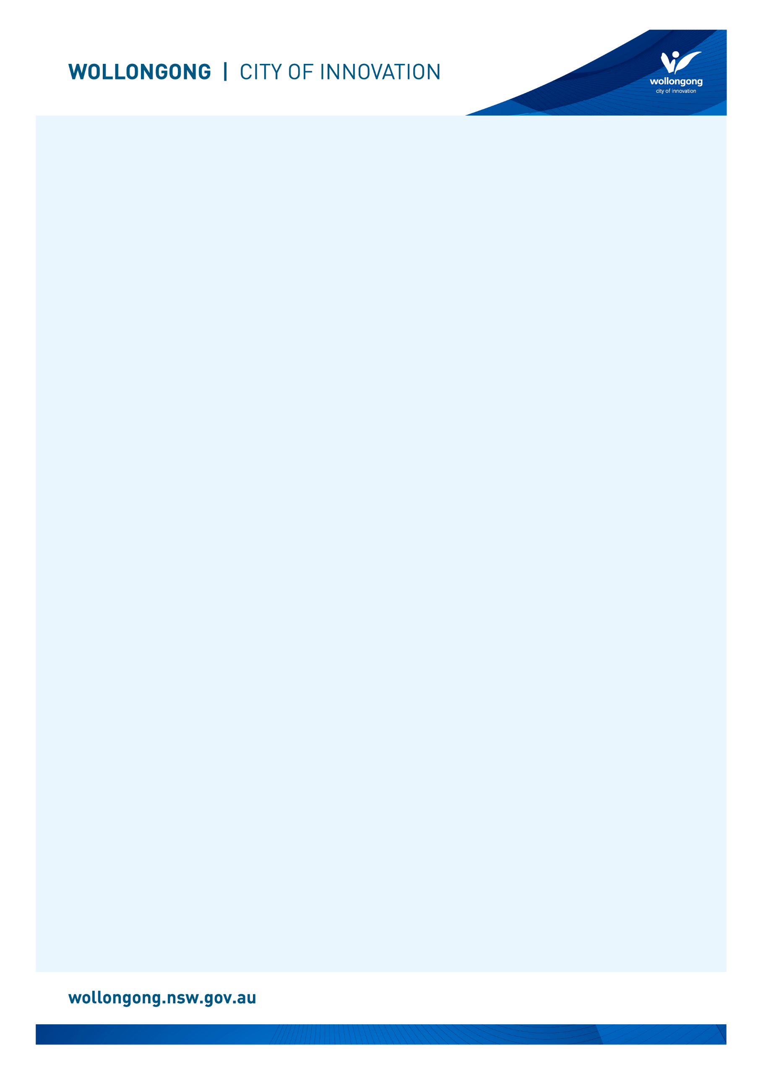

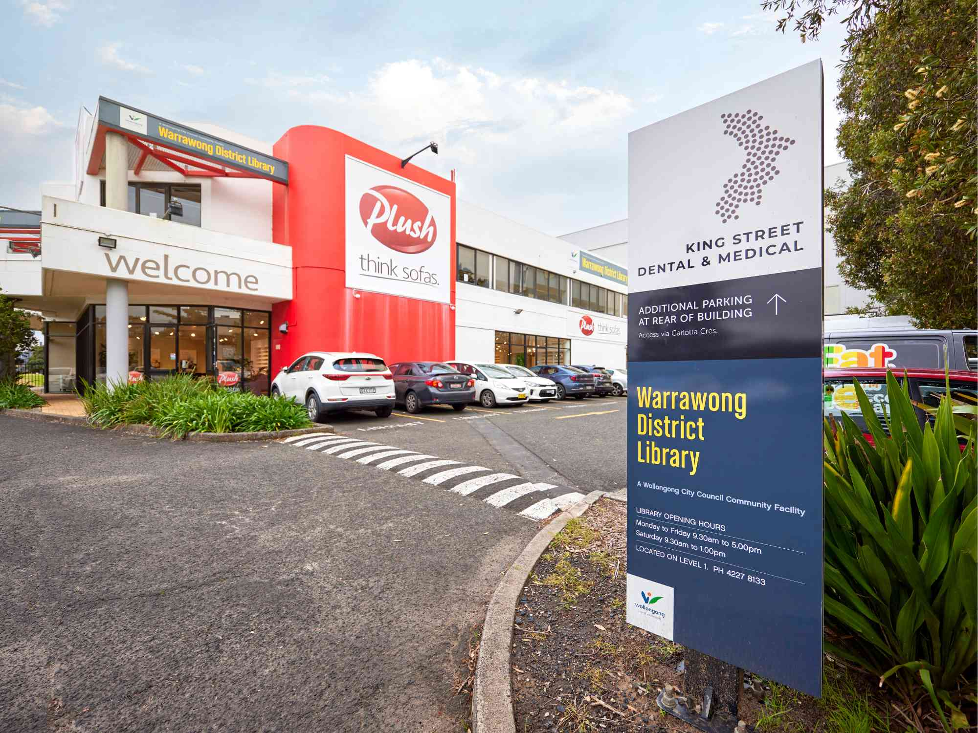

# Going to

# Warrawong Library

## Before I go to the library

|  |  |
| --- | --- |
| I’m going to Warrawong Library. | Glass doors with a black frame at the front entrance to Warrawong Library. |
| If I am nervous about going, I can talk to someone and ask questions first. I can phone Warrawong Library on (02) 4227 8133. | A librarian in a blue and white striped shirt is sat on a chair while talking on the phone. |

## About the library

|  |  |
| --- | --- |
| There are people who work at the library who I can talk to. | A librarian with short brown hair is smiling at the camera and holding a picture book. |
| The library is usually a quiet place where people talk quietly, relax and read books. | A grey chair-shaped beanbag with a blue pillow on it next to a small glass table and a blue chair-shaped beanbag. |
| Sometimes it might be loud. If it gets too noisy, I can ask the library staff for help. | A group of women sitting on the floor with babies inside the library. They are participating in a children's program. |

## How I become a member of the library

|  |  |
| --- | --- |
| When I get to the library I will see a desk. | A librarian with blonde hair is standing behind a computer at the front desk of Warrawong Library and smiling at the camera. |
| I will talk to someone who works there to become a library member. | A librarian with blonde hair is standing behind the front desk at Warrawong library with an orange library card in her hand. |
| I will tell them my name, address, date of birth, telephone number, and email address. | A librarian is standing behind the front desk and assisting a customer. |
| I will need to bring one form of identification with my name and address, such as a driver’s licence or concession card. | A graphic representation of a blue and white ID card. |
| I'll answer some questions and learn about borrowing. I will receive a library card, and this makes me a library member. | Four Wollongong City Libraries' library cards, in the colours gold, orange, blue and pink. |

## When I visit the library

|  |  |
| --- | --- |
| In the library there will be shelves of books, CDs, DVDs, and magazines. | A shelf filled with books at Warrawong Library. |
| I can sit in a chair to read a book. | A woman with brown hair is sitting in a black leather chair reading a book. |
| I can borrow a book, CD, DVD, or magazine and take it home with me for four weeks. | A close up of hands searching through the DVDs at Warrawong Library. |
| If I want to borrow a book, CD, DVD, or magazine I will talk to a library staff member. | A librarian smiling at the front desk of Warrawong Library. She has brown hair and wears glasses. |
| The staff will show me how to borrow the book, CD, DVD, or magazine and tell me when I need to bring it back to the library. | A close up of a customer scanning their library card on a self-checker machine. |
| The library will also have some computers. | A row of public computers at Warrawong Library. The computers are sat on a brown desk with a red partition. |
| The computers are free to use with my library card. | A woman is sat in a chair in front of a public computer at Warrawong Library. |
| One of the computers has a Vision Australia keyboard for people with low vision. | A Vision Australia keyboard at a Dapto Library computer which has very large black text on yellow keys to help people with low vision. |
| The library has some sensory tools I can borrow when I am in the library. I can ask a library staff member to borrow sensory tools. | A pile of sensory tools including headphones, two tangle fidgets, liquid motion sand timer, a silicone pop ball and a plush turtle. |
| I can use the bathroom at the front of the library, near the help desk. | A red and silver door that leads to the bathrooms at Warrawong Library. |
| When I have finished, I will leave the library through the main door. | An internal view of the glass front door to Warrawong Library. |
| I’ll come back to my library to return the things I borrowed and find new things to take home! | A blue metal box with a silver handle - the Warrawong Library external returns chute. |
| I can use the return chute outside or inside my library to return what I borrowed. | A brown desk with a hole in it underneath a sign that says "Library Returns." This is the internal library returns chute. |

We look forward to seeing you at Warrawong Library again soon!

[](https://www.google.com.au/url?sa=i&rct=j&q=&esrc=s&source=images&cd=&cad=rja&uact=8&ved=2ahUKEwivyODlzdzdAhUEXLwKHfQEA64QjRx6BAgBEAU&url=https://en.wikipedia.org/wiki/Moran's_I&psig=AOvVaw0mKyTROxNryIM0I3cnBMSp&ust=1538186603827848)

**FINISHED**