Neighbourhood Forum 5  Wollongong’s Heartland | 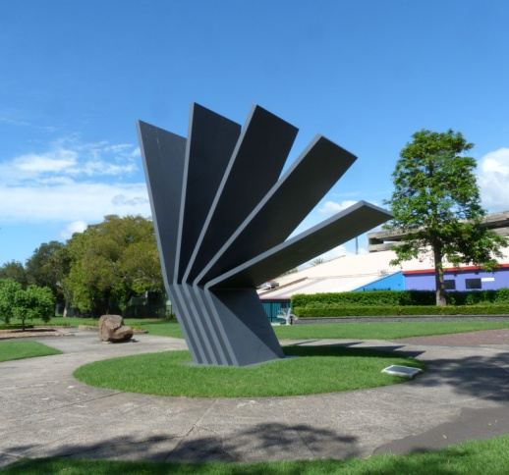 | Coniston, Figtree, Gwynneville, Keiraville, Mangerton, Mount Keira, Mount St Thomas, North Wollongong, West Wollongong, Wollongong City.

Agenda for meeting at 7.00 pm Wed. 1st May 2019 in the Town Hall Ocean Room

1 Presentations Kerry Hunt, Director of Community Services, Chris Stewart, Manager City Strategy, and Mike Dowd, Manager Infrastructure Strategy on the WCC Delivery Program and Operational Plan, 2019.
2 Apologies
3 Minutes of meeting of 3rd April 2019 and matters arising.

4 Comments from residents, Councillors and/or Council staff.
DA townhouses, 58/60 Murphys Ave Keiraville: see p.10 (Eric Kivi)
Roundabout on Gipps Road: see p. 7 (Vic Meglenci )

5 Responses Crown Street Art Work: see p 5
Delivery Drones: see p.5
Mount Ousley Interchange: see p.6
No responses: see p.6

6 Reports WCC Delivery Program and Plan: see pp 12-14 and recs pp 6 & 7
F6 Extension: see rec p.7
Botanic Gardens Duck Pond: see p. 6 & rec p.7
Cycleway Signage Community Grant: see rec p.8
Vale Brian Reid: see p.8

7 Activities Keiraville/Gwynneville Access Study: see p 8
University: see p 9
South Wollongong: see p 9
Neighbourhood Forums Alliance: see p 9
Bluescope Community Consultative Committee: see p.9

8 Planning DAs: see recs p 9 & 10

9 General Business:
10 Snippets see p 11
Next Meeting: 7.00 pm on Wed. 5th June 2019, Town Hall Ocean Room.

Current active membership of Neighbourhood Forum 5 : 390 households

Neighbourhood Forum 5  Wollongong’s Heartland |  | Coniston, Figtree, Gwynneville, Keiraville, Mangerton, Mount Keira, Mount St Thomas, North Wollongong, West Wollongong, Wollongong City.

Minutes of meeting on Wed. 4th April 2019 in the Town Hall Ocean Room

Present 17 members and Cllr Tania Brown

1 Presentation. Mark Roebuck was thanked for his update on current Council works and for responding to queries.

2 Apologies were accepted
3 Minutes of meeting of 6th March 2019 were adopted.

4 Comments Cllr Brown reported back on a number of issues that had been raised at the last meeting and was thanked for her support.

5 Responses Implementation of Wollongong Pedestrian Plan
It was agreed to review this against the latest draft Operational Plan and Delivery Program.

Air Conditioners: noted

Sir Alexander Stuart Memorial
It was agreed to ask Council about the timing of the review of the Blue Mile Strategy and what and when will community engagement occur.

Grass Clippings: noted

Use of Roundup: noted

Crown Street Footpaths
It was noted that the council endorsed Implementation Plan for Public Spaces Public Lives (at 6.6 page 10) shows the works were funded in the Capital Progam and due to be delivered in 2017/18.
It was agreed to ask Council why it was now necessary to wait two years for a Masterplan before implementing what was due to be completed last year.

Current active membership of Neighbourhood Forum 5 : 386 households
Raised Pedestrian Crossing on Berkeley Road, Gwynneville.
It was resolved to request Council to ensure that this is in the budget for 2019-20, given ongoing concerns by the school and the risk to children.

Water Discharge into Gutters
It was resolved to thank Council for their efforts and response to this issue.

6 Reports Local Character and Place Guideline : noted.

On-Call Household Cleanups
It was agreed to thank Council for their consideration and co-operation and that we look forward to viewing options for improvements to the system.

7 Activities Keiraville/Gwynneville:
It was noted that it is 5 years since the major community initiative took place and the Implementation Plan adopted by Council with the Access Study being perhaps the most important outcome.

It was noted with regret that although only just promised for the end of March the Strategy is still not available. It was noted with even more regret that Council declined to present the latest results to this Forum meeting.

It was agreed to request Council to present results to the May meeting, particularly given the on-going traffic chaos around the University.

It was also agreed that the issue be drawn to the attention of Councillors and Council staff.

North Wollongong
Given two years of engagement by the community with Council staff it was agreed to again request Council to bring forward the timing of the footpath on the east side of View St.

South Wollongong & City Centre:
It was agreed to set up a sub-committee to review progress on the Public Spaces Public Lives targets against the latest Operational Plan and Delivery Program.

Neighbourhood Forums Alliance: noted

University: noted

8 Planning DA/2019/160 3 storey Shop-top Housing 51 Kenny St Wollongong It was agreed that:
1 the decision not to make a submission be confirmed;
2 Council be requested:
i to review site width requirements for Mixed Use developments involving only one or two dwellings;
ii re-zone this area from Enterprise Corridor (which it is clearly not) to Mixed Use.

DA/2019/223 2 storey dual occupancy 20 Lauder St Mangerton
It was agreed that the submission of objection be confirmed.

DA/2019/228 2 storey dual occupancy 138 Robsons Rd W. W'gong
It was agreed that a submission of objection be lodged.

9 General Gareth Ward, MP
Business It was agreed to congratulate Gareth Ward on his elevation to cabinet and request him to seek to expedite the funding of the Princes Motorway interchange to the University, given escalating traffic congestion in the area. Also to ask him when the re-draft of the Public Interest Act is due to be available.

NF 5 Agenda on Council Web Site
The Forum was advised that the agenda for this meeting was not posted until late on the morning of the meeting. Receipt by Council of the agenda was received on the previous Thursday evening.
It was agreed to request Council to review processes for listing the agenda on their web site.

Crown Street Art Work
The Forum was advised of community disquiet at the "art works" in the mall. The image of mutilated Palm Trees and a chaotic clutter of sandstone blocks, and the way in which the design selected, does not reflect many of Council's endorsed Community Goals.
It was agreed to ask Council for how long it was anticipated that the "art works" would remain and that they be replaced as soon as possible.

Delivery Drones
The Forum was advised of potential noise problems, particularly late at night, from delivery drones.
It was agree to request Council to investigate the implications of drone deliveries and their control and management.

Cliff Road Gun Emplacement
It was agreed to request Council to inspect and repair the corroding guns at the Cliff Road Emplacement.

Next Meeting: 7.00 pm on Wed. 1st May, 2019, Town Hall Ocean Room.

5 Responses Crown Street Art Work
This artwork has been designed to foster debate and commentary and provide a talking point in the Mall. It was the artist’s intention for the pieces to work together from Church Street down to Kembla to provide texture and contrast to the Mall’s environment. The artist worked closely with a local arborist and palm experts to ensure the palms are able to grow in the locations installed.
All the palms have been provided with an irrigation system that will provide nutrients and the concrete pavement under the palm seats has been removed to allow the palm to access the soils below. The sandstone rocks have been designed to be climbed and played on by children and incorporate a local flavour having been quarried at Bundanoon in the Southern Highlands. This is a long-term installation to complement our goal of a creative and vibrant city.
Community + Cultural Development Manager (Acting)
Comment Members will have to make up their own minds on this both as the image for the City and for marketing generally.

Delivery Drones
"At this stage there is not a specific requirement / guideline in regards commercial drone noise emissions. There is however, a framework of regulation established within existing legislation that would likely be involved in any management of noise from drones.
Any potential drone delivery operation would likely involve development consent and assessment and any potential impacts caused by the operations of any such business would be regulated under the Environmental Planning & Assessment Act 1979 as well as the Protection of the Environment Operations Act 1997. In addition any delivery operations undertaken by drones would be subject to Civil Aviation Safety Authority (CASA) registration and accreditation and all operators would be required to be commercially licensed. In addition CASA requirements for drone operations also currently include time limit restrictions.
I am advised a trail of drone delivery operations has recently been completed in the ACT and the feedback regarding this trial (and any other future trials) will also likely inform the process. If the phenomenon of commercial drone deliveries increases it is likely that regulatory tools for government will also be reviewed as required.
Manager Regulation + Enforcement
Mount Ousley Interchange
We sought help from Gareth Ward to expedite this. " As Minister Ward is no longer the Parliamentary Secretary for the Illawarra and South Coast he no longer deals with the matters you have raised as they are outside of his electorate and outside of his Ministerial responsibilities. I strongly suggest that you either contact your local Member for Parliament or the Parliamentary Secretary for Regional Roads – Mr Christopher Gulaptis MP."

We checked: "The Parliament has not yet received formal notification from the Department of Premier and Cabinet regarding the appointment of Parliamentary Secretaries. We anticipate receiving formal notification before Parliament returns in early May."

No response as yet:
NF 5 Agenda on Council Web Site
Crown Street Footpaths
Cliff Road Gun Emplacement

6 Reports WCC Delivery Program and Operational Plan,2019
(Community Strategic Plan, Delivery Program and Operational Plans)

We are fortunate in having three senior Council officers coming to the meeting, primarily to respond to your questions, so take a look at the Plans and come prepared. They will start with a brief overview of the Plans and then we have asked them to comment on our Annual Plan Report: see Attachment p.12-14.

The Plans comprise some 430 pages making it difficult for the community, and we suggest Councillors, to relate to every issue. This is made more difficult because Program and the Annual Service Plans and they do not always mesh so there may be some misunderstandings in the comments.

However, Sally Anderson and Rebecca Jardim have been through the documentation in some detail as it relates to our area and will present this to the meeting.

Some of Neighbourhood Forum 5 submissions to previous years' Annual Plans were accepted and information given on some of the others. For a number of items, however, the responses seemed to be less than satisfactory so that they are re-submitted together with those for this year.

Recommendations
Council be advised that the Forum:
1 supports all the proposals which relate to their area;

2 seeks discussion/input into major Studies and Investigations and requests information on the timing of these:
i review of Fairy Cabbage Tree Creek Flood Study;
ii City Centre Planning Review - preferably through a Reference Group;
iii City Wide LEP Review - preferable in association with Neighbourhood Forum Alliance and the preparation of the Local Planning Strategy Statement;
iv Development of Crown Land Plans of Management;
v updated Landscape Master plan for Stuart and Galvin Parks, North Wollongong;
vi review of Inner City Parking Strategy;
vii the Integrated Transport Strategy;
viii Review of Wollongong City Centre Access and Movement Strategy 2013-23;
ix review of the Wollongong Bike Plan;
x development of an Integrated and Sustainable Transport Strategy;

3 comments, as noted in the attachment, with amendments and additions as moved at this meeting.

Roundabout on Gipps Road
"I and many other residents in the Gwynneville & Keiraville area would like to see a new round about installed at the busy intersection located at Gipps road / Francis Street & Berkeley road, in Gwynneville. This will greatly assist the current traffic concerns evident every day, and especially during school hours and peak times".
Vic Meglenci

F6 Extension Stage 1 9th May
The government is continuing to put this self defeating road project ahead of funding improvements to the South Coast Rail line. There are a range options for the medium and long term, but an immediate need to add extra carriages and improve mobile phone reception.

Recommendation
That an objection be lodged to the latest Stage of the F6 Project and Ryan Park MP be supported in his endeavours on rail services..

Botanic Gardens Duck Pond
The Duck Pond water reserve is an integral part of the Botanic Garden which has now silted up significantly and has become shallow affecting circulation and water quality. Water from the pond is recirculated through the Gardens creek system. Also, dredging of the pond is a prerequisite if a permanent cafe is sited at the edge of the pond.

The final version of the Master Plan will be presented to Council for approval this year with a priority list of capital expenditure items for future budgets.
Felix Bronneberg
Recommendation
Council be requested to include the urgent dredging of the Duck Pond at the Botanic Garden in the current budget.

Cycleway Signage Community Grant
The NSW Government is providing funds for Community Projects. The Illawarra Bike Users Group suggest that we join with other Neighbourhood Forums in applying for a grant to provide better signage on cycle routes.

Recommendation
That the Forum support the grant application for such a grant.

Brian Reid
Members will be saddened to hear of the death of Brian Reid a long time and strong supporter of the Forum.

7 Activities Keiraville/Gwynneville Access Study
We are now advised - " In response to your request for the results of the Keiraville/Gwynneville Access Study to be presented at the May Neighbourhood Forum 5 meeting, Council have sent a copy of the draft strategies to UOW for their comment. Once council has received their comments we will update the strategies and forward a copy to NF5 for their comment. Unfortunately this means that we will not be in a position to present to the May meeting".

Comment
We were promised that a draft would be sent to us and the University by the end of March. We asked them to present to the April meeting. They refused. We then asked them to present to this meeting. They again have refused on the grounds they have not yet had a response from the University. Now they are saying we might not be able to respond until June - this is quite ridiculous - that will be nine months since our last (and we thought positive) workshop. If this because there have been massive changes why have they not been discussed with us before now? Worse, there is now little hope of getting projects into next year's budget. No wonder people feel betrayed after all the time and effort the community has put into this.

The Manager Infrastructure should be quizzed on this at this meeting. Earlier it seemed that the Council, and particularly the Infrastructure Division, was moving from engagement towards participation but, at least on this project, they seem to be going backwards. Council's reputation for open and transparent government and its pseudo goal to be a "connected and engaged community" is becoming a mockery.

South Wollongong
Any suggested changes to the zoning or to the flood regime should be put to the Manager City Strategy and the Manager Infrastructure at this meeting.

Neighbourhood Forums Alliance
Members plan to meet on 13th May. They will be reviewing proposals for Transition Areas in each Ward and possible incentives for medium density development in them. NF 5 members are encouraged to come if they can: let the secretary know to receive a report in advance.

Bluescope Community Consultative Committee
The meeting was advised that Bluescope has had a record financial result and has introduced a profitshare scheme with employees. Some 250 people, from 5,000 applicants, have been put on in the last 12 months, and the female participation rate is increasing. 650 employees turned up for the Clean Up Australia Day.

8 Planning
DA/2019/286 Dual Occupancy, 2 Eastern St Gwynneville
16thApril
This is a proposal for a dual occupancy on a corner lot with unit facing each street. It complies with all Council requirements save that one lot has two storey section closer to the rear boundary than the minimum 8m. The wall has windows in it. Apart from this, the proposal complies, just, with our Locality Plan for Keiraville. | 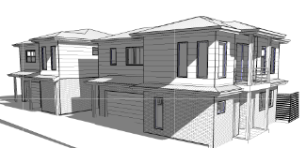

Recommendation
That the submission of support be endorsed subject to the rear setback of the dwelling on Lot 1 be complied with and/or windows eliminated.

DA/2019/292 Dual Occupancy, 28 Abercrombie St West W'gong
17thApril
This is a proposal for a dual occupancy with a second, single storey, house being built behind the existing house so the streetscape does not change. It complies with all Council requirements and with our Locality Plan for Figtree. | 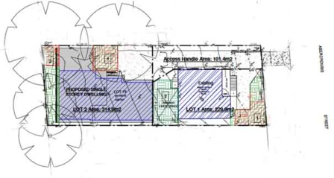

Recommendation
That the submission of support be endorsed.

DA/2019/330 Gymnasium, 149 The Avenue, Figtree
29thApril
This is a proposal for a two storey gymnasium at the back of a lot adjacent to the access to Lysaghts Oval. It complies with all Council requirements save the implied restriction of a two storey building within 8 m of the rear boundary. However, in circumstances of this site this is not an issue and the proposal will complement services available in Figtree Grove. | \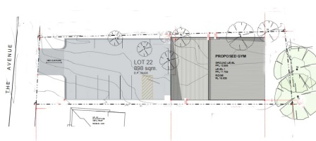

Recommendation
That the submission of support be endorsed.

DA/2019/284 10 townhouses, 58/60 Murphys Avenue Keiraville
extended to 3rd May
This is a proposal for two 2 storey buildings each containing 5 townhouses on a curiously shaped, deep, lot well to west of Robsons Road. It claims to comply with all substantial Council requirements but is totally out of character and scale with the area. It epitomises all we have been objecting to in all our Locality Plans with a gross intrusion into an area of single family houses in a relatively remote location. There should be a maximum of four dwellings on this site. | 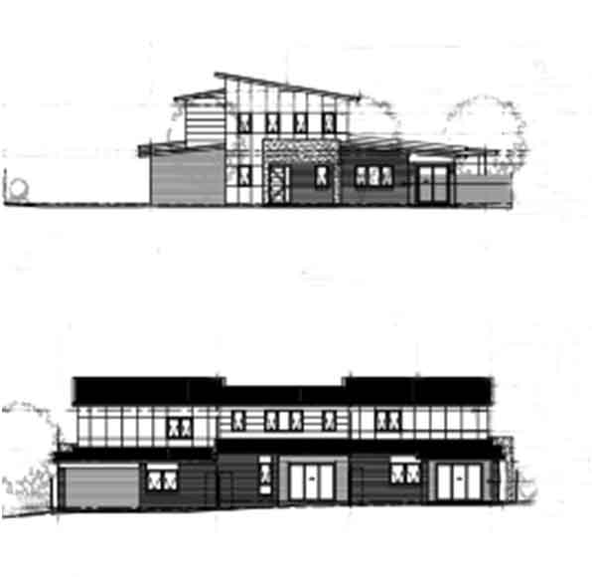

Recommendation
That a submission of objection be lodged.

9 General
Business

10 Snippets Pre-application Discussions

In English planning practice (and Wollongong's!) pre-application discussions between local planning authorities and developers can voluntarily take place prior to a formal planning application being submitted for decision. Many regard pre-applications as useful as they may clean up proposals that could clog up the system due to their lack of consideration of policy, or due to their complexity or to nuanced circumstances that need deliberation.

Pre-applications are notable as they are usually conducted without community input. More could be done to put them on a firmer footing in terms of how and why they are triggered and who is involved. Specifically the pre-application stage should add transparency and improve community trust and to aid the maintenance of public interest in a system in which short-term market needs and developer interest has become overly dominant.

If it is satisfactory to iterate practice and policy designed to deregulate planning and to strengthen market confidence, then it must be legitimate to discuss and possibly introduce measures which counter-balance such reforms. This can be aided by improving the negotiating positions of the community and the local authority.
Gavin Parker and Tomokazu Arita,

I Can't Believe What I'm Hearing

Annual Service Plans (ASP) ATTACHMENT

Item numbers in bold to be advised to Council

Item | Service | Submissions and re-submissions | Previous Response (R.) and Comment (C.)
1 | Botanic Garden | Refurbishment of Glasshouse in time for Centenary | Requested - 2018  R. design in ASP  C. needs to be funded
2 | Botanic Garden | New cafe and the necessary sub-station | Requested - 2018  R. not in ASP  C. needs to be funded
3 | Botanic Garden | Dredging duck pond | Requested - this agenda  R. not in ASP  C. needs to be funded
4 | City Centre Management | Include a Community Reference Group. | Requested - several 2011 to 2018  R. no response recorded.  C. decisions made in isolation.
5 | Communications, Engagement, Events and Signage | Include more resources and support for Neighbourhood Forums to bolster the way the community sees Council engages with them. | Requested 5th May 2016  R. in next Charter review  C. review not in ASP.
6 | Communications, Engagement, Events and Signage | Include an investigation on how better to harness community resources and expertise | Requested 5th May 2016 &17  R. - not necessary as is current engagement practice  C. - much more should be done.
7 | Communications, Engagement, Events and Signage | Include specific reference to Neighbourhood Forums as achieving the goal of a connected and engaged community. | Requested 5th May 2016 &17  R. - not necessary as is current engagement practice.  C. - NFs disempowered
8 | Community Facilities | Include a review to ensure the Town Hall and its organ are fully used by community groups. | Requested May 2017  R. Acknowledged  C. action now taken.
9 | Crematorium & cemeteries | Assess the opportunity to sell Council facilities which are in competition with the private sector. | Requested 5th May 2016 & 17  R. - under consideration.  C. no longer on radar
10 | Development Assessment | Include a review of the way in which DAs are notified to reflect the actual proposal. | Requested 5th May 2016 & 17  R. changes have been made.  C. good.
11 | Development Assessment | Include a requirement for applicants to indicate performance on the robust building scale. | Requested 5th May 2016 & 17  R. - consider in next DCP review  C. - not scheduled before 2020/21
12 | Financial Services | Include a review of CBD rate inequities | Requested 5th May 2016 & earlier  R. to be considered as a "Special Rate Variation" after 2016/17  C. not a variation but fundamental
13 | Infrastructure Planning | Include a review pedestrian/cycle conflict on Cliff Road | Requested 5th May 2016 & 18;  R.- project started;  C. still not resolved satisfactorily.
14 | Infrastructure Planning | Include converting on street parking on the eastern side of Crawford Ave. to a dedicated bikeway - a strategic route. | Requested 5th May 2016  R. - future consideration  C. now in budget for 2019/21 but only as a shareway.
15 | Infrastructure Planning | Include an up-date of the Allan's Creek Flood Study | Requested Nov 18  R. - not a priority  C. not urgent
16 | Land Use Planning | Include processing the Planning Proposal for Keiraville/Gwynneville | Requested 5th May 2016.  R. NF 5 withdrew Proposal.  C. temporally, under duress!
17 | Land Use Planning | Include in City Centre Planning Review revising the DCP desired future character statement for the City Centre to ensure respect for the existing streetscape. | Requested 4th November 2016  R. to follow planning review.
18 | Land Use Planning | Include a DCP Chapter on the development of the University of Wollongong campus. | Requested 5th May 2016'  R. - under consideration  C. not included in Land Use ASP.
19 | Land use Planning | Accelerate timing of Housing Study and involve the community. | Requested 5th May 2016 and later,  R. to be done in-house.  C. was due in June 2018.
20 | Land use Planning | Include in City Centre Planning Review removing anomalies and rationalising setback controls for residential development | Requested 6th October 2016  R. to follow planning overall review.  C. re-iterate
21 | Land use Planning | Include in City Centre Planning Review changing requirements for building separation in the City Centre | Requested 4th November 2016 -  R. to follow planning overall review.  C. re-iterate
22 | Land use Planning | Improve the Desired Future Character statements in the DCP for land zoned R1 | Requested 4th November 2016 -  R. no response recorded.  C. re-iterate
23 | Land use Planning | Amend the DCP to extend the single storey restriction to all development on battle-axe lots and to clarify site width definition. | Requested 5th August 2016 -  R. no response recorded.  C. re-iterate
24 | Land use Planning | Amend Chapter E3 of the DCP to require parking spaces needed for customers to be clearly marked and signposted (as with visitor parking) | Requested 5th August 2016 -  R. impossible to police.  C. causes chaos in some places, how is visitors' parking policed?
25 | Land use Planning | Amend Chapter B1 Residential Development to prefer deep soil zones within the front setback, not merely allow it. | Requested 7th July 2016 -  R. apparently ignored or implicitly rejected.  C. crucial to greening the city
26 | Land use Planning | Amend Chapter B1 Residential Development and Chapter D 13 City Centre to require all buildings over four stories to have at least 50% of green roofs or solar panels. | Requested 7th July 2016  R. apparently ignored or implicitly rejected.  C. crucial to greening the city - follow the Paris lead.
27 | Parks & Sportsfields | Prepare and adopt a Master Plan for McCabe Park. | Requested 5 May 2016 & later  R. planned for 2017/19  C. not in ASP.
28 | Parks & Sportsfields | JJ Kelly Park improvements and flooding issues | Requested Nov Nov 18  R. available Nov 19  C. Good
29 | Land Use Planning + Parks & Sportsfields | Local open Space in North Wollongong | Requested Mar 19  R. no response recorded.  C. re-iterate
30 | Transport Services | Include in the up-grade of the Cycleway Strategy setting out priority criteria and specifying type for each route. | Requested 5th May 2016 -  R. - already in Cycle Plan  C. type not specified and priorities need to be grouped.
31 | Transport Services | Availability of the Keiraville-Gwynneville Access Study | Numerous requests over 5 years  R. available March 2019  C. It wasn't
32 | Transport Services & Land Use Planning | Amend Chapter E3 Car Parking, etc, and Chapter D 13 Wollongong City Centre be amended to require, not just encourage, applicants to implement a green travel plan if the proposal for substantial commercial, institutional or industrial purposes. | Requested 7th July 2016  R. none recorded.  C. another opportunity to address sustainability and climate change missing.
33 | Waste Management | Due to deficiencies and omissions review the Strategy and Action Plan with an effective community engagement process. | Requested 23rd May 2014 & later  R. none recorded.  C. remains a very costly black hole.

